Decision Support System (DSS)
FY 2016 Extracts

USER MANUAL



Software Version 3.0
Revised: November 2015

Department of Veterans Affairs
Office of Information and Technology (OIT)
Product Development

Revision History
Date | Description (Patch # if applicable | Author
08/17/2015 | Manual updated for FY16 changes in Patch ECX*3.0*154 | Charlie Wilbur
07/22/2014 | Manual updated for FY15 changes in Patch ECX*3.0*149 | Charlie Wilbur  Radha Sivasamy
10/31/2013 | Manual updated for FY14 changes in Patch ECX*3.0*144 | Megan Lucas
11/1/2012 | Manual updated for FY13 changes in Patch ECX*3.0*136 | Megan Lucas
08/01/2011 | Manual updated for FY12 changes in Patch ECX*3.0*132 | Megan Lucas
10/15/2010 | Manual updated for FY2011 changes based upon the following Patches: ECX*3.0*127, LR*5.2*403 and SD*5.3*568 | Tavia Leonard
9/30/2010 | Updated formatting for this document based upon OED National Documentation Standards | Tavia Leonard
11/05/09 | Updates for FY10 changes | K Peacock
11/01/09 | Manual updated for FY10 changes in Patch ECX*3.0*120 | Corinne Bailey
11/01/08 | Manual updated for FY09 changes in Patch ECX*3.0*112 | Tom Rochford
11/01/07 | Manual updated for FY08 changes in Patch ECX*3.0*105 | Berry Anderson  Corinne Bailey
11/08/2006 | Manual updated for FY07 changes in Patch ECX*3.0*92 | Berry Anderson
11/18/2005 | Manual updated to include changes due to Patch ECX*3.0*84 | Berry Anderson
03/17/2005 | Manual updated to include changes due to Patch ECX*3.0*72  See sections:  Enter/Edit DSS Stop Codes for Clinics  DSS Identifier Non-Conforming Clinics Report | Berry Anderson
03/09/2005 | Manual updated to include Patch ECX*3.0*78 | Mary Ellen Gray
12/17/2004 | Manual updated to include changes due to Patch ECX*3.0*71 | Berry Anderson
11/15/2004 | Manual updated to comply with SOP 192-352 Displaying Sensitive Data | Corinne Bailey

Table of Contents
1 Introduction 5
1.1 Related DSS Manuals 5
2 Orientation 6
2.1 Components of this User Manual 6
2.2 User Responses 6
2.3 Online Help 6
3 Before You Start Using the Software 7
3.1 Setup Required DSS Information 7
3.2 The Security Keys Structure 7
3.3 Logon/Accessing DSS Options 8
4 Extract Manager’s Menu 9
4.1 Maintenance Menu 9
4.1.1 CBOC Activity Report 9
4.1.2 CPT Inquiry 10
4.1.3 DSS Department Management 11
4.1.3.1 Enter/Edit DSS Ward 11
4.1.4 Event Capture 12
4.1.4.1 Unusual Volume Report for Event Capture 12
4.1.5 Laboratory 15
4.1.5.1 Add/Edit Lab Results Translation Table 15
4.1.5.2 Lab Results Extract Untranslatable Results Report 17
4.1.5.3 Lab Results DSS LOINC® Code Report 18
4.1.6 Pharmacy 19
4.1.6.1 Pharmacy Edit and Edit Log 19
4.1.6.1.1 Pharmacy Volume Edit 19
4.1.6.1.2 Pharmacy Volume Edit Log 23
4.1.6.2 Pharmacy Extracts Incomplete Feeder Key Report 24
4.1.6.2.1 Example PRE Extracts Incomplete Feeder Key Report 25
4.1.6.2.2 IVP Extracts Incomplete Feeder Key Report 26
4.1.6.2.3 UDP Extracts Incomplete Feeder Key Report 28
4.1.6.3 Pharmacy Extracts Unusual Cost Report 29
4.1.6.3.1 PRE Unusual Cost Report 30
4.1.6.3.2 IVP Unusual Cost Report 31
4.1.6.3.3 UDP Unusual Cost Report 32
4.1.6.4 Pharmacy Extracts Unusual Volume Report 33
4.1.6.4.1 PRE Unusual Volume Report 33
4.1.6.4.2 IVP Unusual Volume Report 34
4.1.6.4.3 UDP Unusual Volume Report 36
4.1.6.4.4 BCM Unusual Volume Report 38
4.1.6.5 UDP/IVP Source Audit Report 40
4.1.7 Print Feeder Keys 41
4.1.8 Print Feeder Locations 42
4.1.9 Prosthetics 43
4.1.9.1 Cost by PSAS HCPC Report 43
4.1.9.2 Prosthetic Extracts Unusual Cost Report 45
4.1.9.3 Prosthetics (PRO) YTD HCPCS Report 46
4.1.9.4 Prosthetics (PRO) YTD Laboratory Report 49
4.1.10 Setup for DSS Clinic Information 50
4.1.10.1 CHAR4 Codes List 51
4.1.10.2 Create DSS Clinic Stop Code File 51
4.1.10.2.1 New Clinic Entries 52
4.1.10.2.2 Existing Clinic Entries 53
4.1.10.3 Clinics and DSS Stop Codes Print 53
4.1.10.3.1 Example All Clinics Option 55
4.1.10.3.2 Example All Active Clinics Option 56
4.1.10.3.3 Example Duplicate Clinics Option 56
4.1.10.3.4 Example All Inactive Clinics Option 57
4.1.10.3.5 Example Unreviewed Clinics Option 57
4.1.10.3.6 Export Clinic Review Report Option 57
4.1.10.4 Enter/Edit Clinic Parameters 59
4.1.10.5 Approve Reviewed DSS Clinic Worksheet 60
4.1.10.6 Stop Code Non-Conforming Clinics Report 60
4.1.10.6.1 Stop Code Non-Conforming Active Clinics Report 61
4.1.10.6.2 Stop Code Non-Conforming Inactive Clinics 62
4.1.10.6.3 Stop Code Non-Conforming Both Active and Inactive Clinics 63
4.1.10.7 Clinic and Stop Codes Validity Report 64
4.1.10.8 Clinic Edit Log Report 66
4.1.11 Setup for Inpatient Census Information 67
4.1.11.1 Trial for Setup Extract 67
4.1.11.2 Generate the Inpatient Setup Extract 68
4.1.11.3 Active MAS Wards for Fiscal Year Print 69
4.1.11.4 Primary Care Team Print 70
4.1.12 Setup for Inpatient Medications Information 70
4.1.12.1 Print IV Room Worksheet 71
4.1.12.2 Enter/Edit IV Room Division 71
4.1.12.3 Pharmacy NDC Lookup 71
4.1.13 Surgery 73
4.1.13.1 SUR Volume Report 73
4.1.13.2 Surgery Extract Unusual Volume Report 74
4.2 Package Extracts 75
4.2.1 Admissions Extract (ADM) 77
4.2.2 BCMA Extract (BCM) 77
4.2.3 Clinic Visit Extract (CLI) 77
4.2.4 Event Capture Local Extract (ECS) 78
4.2.5 IV Extract (IVP) 78
4.2.6 Lab Extract (LAB) 78
4.2.7 Lab Results Extract (LAR) 78
4.2.8 Prescription Extract (PRE) 79
4.2.9 Quasar Extract (ECQ) 79
4.2.10 Prosthetics Extract (PRO) 79
4.2.11 Radiology Extract (RAD) 80
4.2.12 Surgery Extract (SUR) 80
4.2.13 Transfer and Discharge Extract (MOV) 80
4.2.14 Treating Specialty Change Extract (TRT) 80
4.2.15 Unit Dose Extract (UDP) 80
4.2.16 Blood Bank Extract (LBB) 81
4.2.17 Fiscal Year Logic – DSS Testing Only 81
4.3 SAS Extract Audit Reports 81
4.3.1 SAS Extracts Audit Reports Menu 82
4.3.2 SAS Prescription Audit Report 82
4.3.3 SAS Radiology Audit Report 83
4.3.4 SAS Surgery Audit Report 84
4.4 Extract Audit Reports 84
4.4.1 Extract Audit Reports Menu 85
4.4.2 Admission (ADM) Extract Audit 86
4.4.3 QUASAR (ECQ) Audit 87
4.4.4 Event Capture Local (ECS) Extract Audit 88
4.4.5 Laboratory (LAB) Extract Audit 90
4.4.6 Laboratory Results (LAR) Extract Audit 91
4.4.7 Laboratory Blood Bank (LBB) Audit Reports 92
4.4.7.1 Laboratory Blood Bank (LBB) Comparative Report 92
4.4.7.2 Laboratory Blood Bank (LBB) Pre-Extract Audit 93
4.4.8 Physical Movement (MOV) Extract Audit 94
4.4.9 Prosthetics (PRO) Extract Audit 95
4.4.10 Radiology (RAD) Extract Audit 99
4.4.11 Surgery (SUR) Extract Audit 100
4.4.12 Treating Specialty Change (TRT) Extract Audit 101
4.5 Transmission Management 102
4.5.1 Review a Particular Extract for Transmission 102
4.5.2 Transmit Data from Extract Files 103
4.5.3 Summary Report of Extract Logs 105
4.5.4 Delete Extract Files 106
4.5.5 Purge Extract Holding Files 107
4.5.6 Recreate Extract Holding Files 108
5 Glossary 111
6 Index 114
Appendix A Feeder Key Transmission A-1
Appendix B Create a LAR Translation Table B-1
Appendix C Exporting a Report to a Spreadsheet C-1

Introduction
Decision Support System (DSS) Extracts Version 3.0 provides a means of exporting data from selected Veterans Health Information Systems and Technology Architecture (VistA) database modules to a Managerial Cost Accounting Office (MCAO) database resident in the Department of Veterans Affairs (VA) Austin Information Technology Center (AITC).
This transfer is accomplished through a set of extract routines, intermediate files, audit reports, a transmission routine, and a purge routine. Data from VistA packages is stored by the extract routines in the intermediate files, where it is temporarily available for local use and auditing. The data is then transmitted to the AITC where it is formatted and uploaded into commercial software. After the data has been successfully uploaded into the commercial software, it is purged from the intermediate files.
The DSS Extracts software includes the following functionalities:
- DSS Extract field additions and modifications
- DSS Menu additions, modifications and deletions
- New DSS reports and report modifications
- Implementation of the new and/or deleted extracts

Related DSS Manuals
Listed below are the following DSS Extract manuals that are available to view on the VA Software Document Library at the following address http://www.va.gov/vdl/application.asp?appid=35

File Name | Manual Name | Description
DSS_3_FY2016_DD | DSS Extracts V3.0 Data Definitions Guide | Provides detailed information on formatting and defines the data terminology.
DSS_3_FY2016_TM | DSS Extract FY2016 Technical Manual | Describes the DSS Extract technical (high- level) terminology
DSS_3_FY2016_UM | DSS FY2016 Extracts User Manual | Provides an overview of the functionality and enhancements.
DSS_3_FY2016_RN | DSS Extract FY2016 Release Notes | Provides detailed information on the DSS extracts and DSS reports modified for this patch release
The DSS web site is located at the following address: http://vaww.dss.med.va.gov/.

Orientation

Components of this User Manual
The “Using the Software - Extract Manager’s Menu” section of this manual is designed to serve as reference to the user, covering vital aspects of this tool. It is broken into five components.
- Maintenance
- Package Extracts
- SAS Extract Audit Reports
- Extract Audit Reports
- Transmission Management

User Responses
In this manual, user responses are shown in bold type. In most cases, you need only enter the first few letters to increase speed and accuracy. Press the Return or Enter key (which is indicated by the symbol <RET>) after each response. This symbol is not shown, but is implied, following bold type entries.
Enter a caret, (^), at almost any prompt to terminate the line of questioning and return to the previous level in the routine. Continue entering carets to exit the system.

Online Help
Online help is available at many prompts in the software by entering a single question mark (?). This will provide information to help the user answer the prompt. In some instances, entering double (??) or triple (???) question marks will provide more detailed information.

Before You Start Using the Software

Setup Required DSS Information
Use the options in the submenus of the Maintenance submenu of the Extract Manager's Options menu listed below to setup information required for using the DSS Extracts software. Refer to the section titled "Using the Software - Extract Manager's Options" for information about using the options. Refer to the DSS Extracts Version 3.0 Installation Guide for information about installing and implementing the software.
- Setup for DSS Clinic Information
- Setup for Inpatient Census Information
- Setup for Inpatient Medications Information

The Security Keys Structure
This KEY functionality is a function of the Kernel's Key Management functions. These simple adjustments make it possible to assign the [ECXMGR] Extract Manager's Options to a user so that they can view all DSS reporting functionality with the assignment of a single option. The security key then controls only those options that actually create/change data and as such should not be available to all DSS employees.
The ECXMGR key has been assigned to the following menus:
[ECXSCLOAD] Create DSS Clinic Stop Code File
[ECXSCEDIT] Enter/Edit Clinic Parameters
[ECXSCAPPROV] Approve Reviewed DSS Clinic Worksheet
[ECX IV DIV EDIT] Enter/Edit IV Room Division
[ECX LAB RESULTS TRANS EDIT] Add/Edit Lab Results Translation Table
[ECXMENU] Package Extracts
[ECXTRANS] Transmit Data from Extract Files
[ECX WARD DSSDEPT] Enter/Edit DSS Ward

The ECXPVE key has been assigned to the following menu:
[ECX PHA VOL EDIT] Pharmacy Volume Edit

The ECX DSS TEST Security Key has been assigned for the following option:
[ECX FISCAL YEAR EXTRACT] Fiscal Year Logic – DSS Testing Only

Logon/Accessing DSS Options
Depending on your setup and permissions, you may have a short cut to the DSS menu.
This is one method for reaching the DSS Menu:
- Logon to VistA.
- On the Systems Manager Menu, select option: Core Applications
- On the Core Applications Menu, select option: Administrative Services Menus
- On the Administrative Services Menus, select option: Extract Manager's Menu
View the choices that are on the Extract Manager’s Menu and select an option.

Extract Manager’s Menu
The Extract Manager’s Menu [ECXMGR] is the main menu for the DSS. The options listed can vary based on the user’s Security Keys settings, as described above.
Each option expands to a sub-menu giving detailed options for that area.
The remainder of this manual is organized according to the options shown on this menu and its sub-menus.
Example: Extract Manager’s Menu
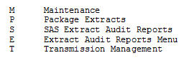

Maintenance Menu
Choosing the Maintenance option from the Extract Manager's Menu will display the following menu and options. Many of these will then display sub-menus and additional options.
Example: Maintenance Menu Options
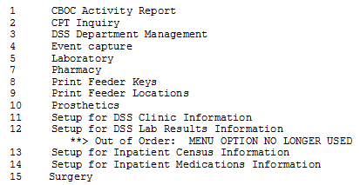

CBOC Activity Report
This report includes information from every Clinical (CLI) record (by extract #) which has a Community Based Outpatient Clinic (CBOC) status of YES. The report is grouped by feeder key, division, and clinic. It lists Patient Name, Social Security Number (SSN) and Date/Time of Visit. Totals for unique SSNs and Visits will be printed for each clinic, division, and feeder key as well as an overall total for the station.
When purging a CLI extract, a check will be made to determine if the CBOC activity report has been run. If the report has not been run, the user will be told that the report has not been run and asked if they still wish to purge the data. If the report has been run, no additional prompts will be seen.
Example: CBOC Activity Report
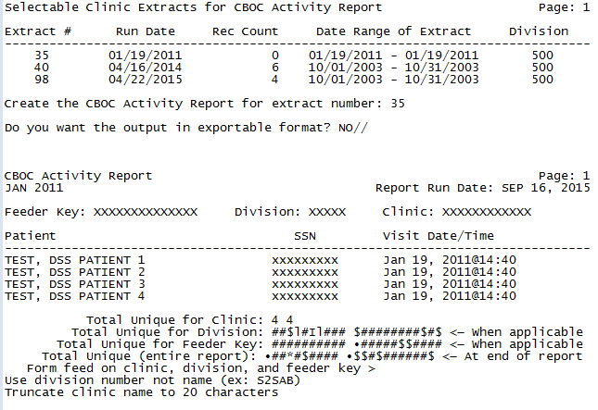
Example: Exported CBOC Activity Report
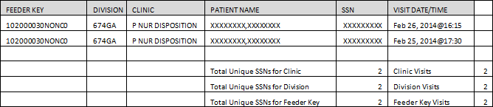

CPT Inquiry
This inquiry allows the user to select a CPT code. It then displays the Short Name, Category, and Description for the selected code.
Example: CPT Inquiry
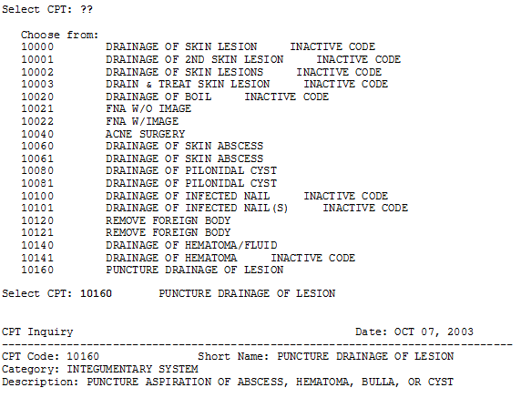

DSS Department Management
Choosing the DSS Department Management option from the Maintenance Menu will display the following sub-menu and options.
Example: DSS Department Management Menu
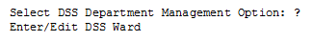

Enter/Edit DSS Ward
This option should only be used by the MCA Site Manager.
Use this option to enter or edit the DSS Department for Ward and suffix, if needed, associated with each medical center ward within your division. If the ward you selected exists in the DSS WARD file (#727.4), the DSS Department Code is displayed and the software asks if you want to edit it. If the ward you selected does not exist in the DSS WARD file (#727.4), the software prompts you to enter a DSS Department for Ward and suffix to complete the DSS Department Code. The suffix must have at least one character, no more than three characters and must not contain an embedded caret. The hyphen character < - > should not be used unless this DSS Department code was previously established in DSS/Austin. After you enter or edit information, the new DSS Department code is displayed and you are asked to verify its accuracy.
Example: DSS Department Management
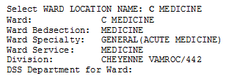

Event Capture

Unusual Volume Report for Event Capture
The Unusual Volume Report for Event Capture is a tool used by managers to validate the EC volume data similar to the use of the Surgery or Pharmacy Unusual Volume Report. It can be used to identify volumes above a user-defined threshold, thus avoiding tedious work by the user. The report should be run prior to information being sent to the DSS database.
The example listed below depicts the report when run for all DSS Units:
Example: Event Capture Unusual Volume Report for All DSS Units
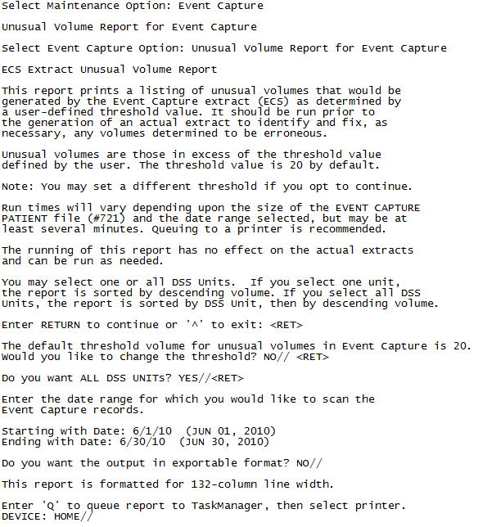
Example: Event Capture Extract Unusual Volume Report
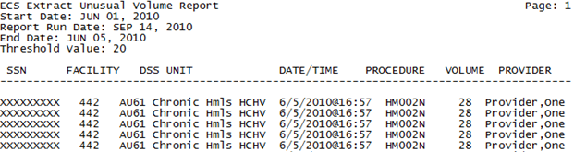
Example: Exported ECS Extract Unusual Volume Report
The following example listed below depicts an example of a report when run for a single DSS Units.
Example: Event Capture Report for a Single DSS Unit
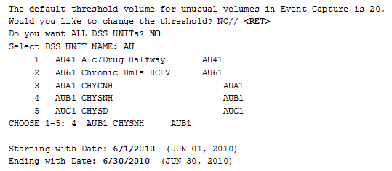
Example: ECS Extract Unusual Volume Report
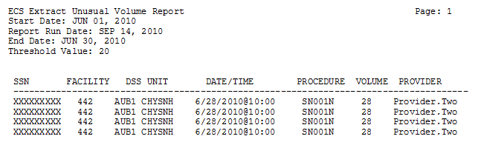
Example: Exported ECS Extract Unusual Volume Report Single DSS Unit

Laboratory
Choosing the Laboratory option from the Maintenance Menu will display the following sub-menu and options.
Example: Laboratory Menu Options
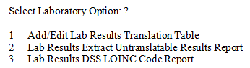

Add/Edit Lab Results Translation Table
This option allows the editing of existing entries or the addition of new entries in the LAB RESULTS TRANSLATION file (#727.7). Free text results (non-numeric) are stored in this file with their corresponding translation codes.
See Appendix B for further information, if necessary.
Example: Add/Edit Lab Results Translation Table
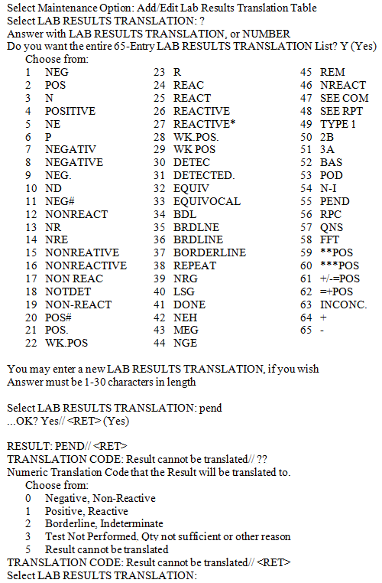

Lab Results Extract Untranslatable Results Report
This report prints a listing of results that are not translatable (have no entry in the LAB RESULTS TRANSLATION file (#727.7)). It is a pre-extract type audit report and should be run prior to the generation of the actual extract. Running this report has no effect on the actual extract.
NOTE: In the printed version of the report to the screen, if the Result field is longer than what can be displayed, a “+” will be appended to the field to indicate there is more text available.
You will be prompted for the date range for which you would like to scan the LAR Extract records. Beginning and ending dates must be in the same month and year.
See Appendix B for further information, if necessary.
Example: Lab Results Extract Untranslatable Results Report
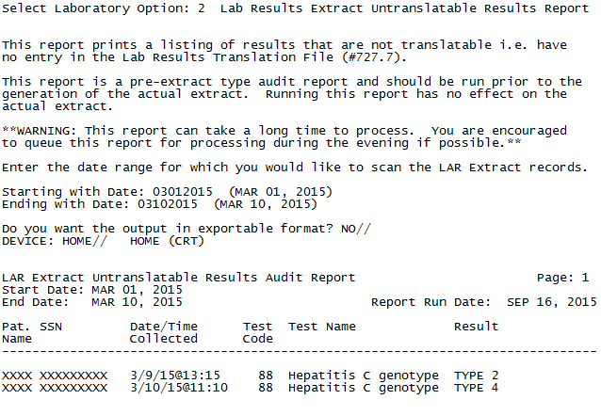
Example: Exported Lab Results Extract Untranslatable Results Report
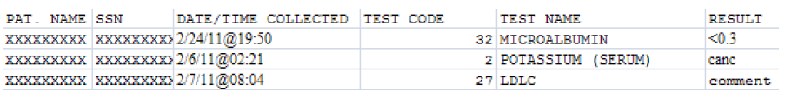

Lab Results DSS LOINC® Code Report
This report prints a listing showing the DSS LOINC® Codes file (#727.29) and its definitions of LAR Test Numbers and the local tests assigned to them. It also compares the LOINC Code assigned by MCAO for a LAR Test to the LOINC Codes found on the local database. The latter is based on the linking of Workload Codes to LOINC Codes at the particular location. Differences are marked with an asterisk following the Local LOINC Code column and must be resolved. MCAO can guide the location with this.
The report displays all workload codes associated with the MCA desired LOINC code. The report prints the values in those columns even if there is no matching workload code found in the LABORATORY TEST file (#60). The intent of the modification is to identify inexact matches and to display all workload codes associated with a MCA desired LOINC code.
The report process attempts to find a matching LOINC code between the DSS LOINC FILE (#727.29) and the WKLD CODE file (#64). If a match is not found, an ‘*’ (asterisk) displays in the FLG column to indicate there is no local workload setup for the desired MCAO LOINC code. None of the ‘local’ fields (those fields coming from file #60 or #64) will be populated.
Example: Lab Results DSS LOINC Code Report
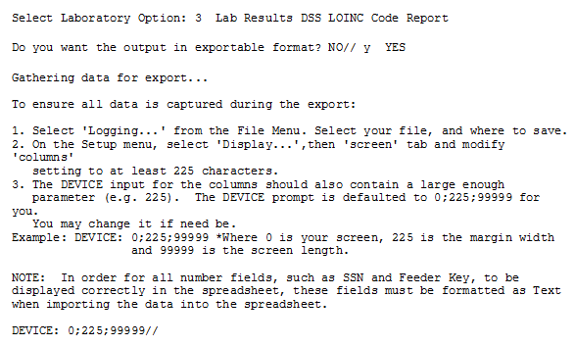
Example: Exported Lab Results DSS LOINC CODE Report
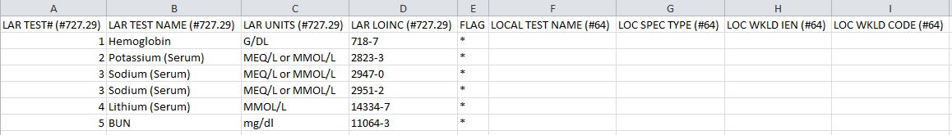
Example: Lab Results DSS LOINC CODE Report Screen Print
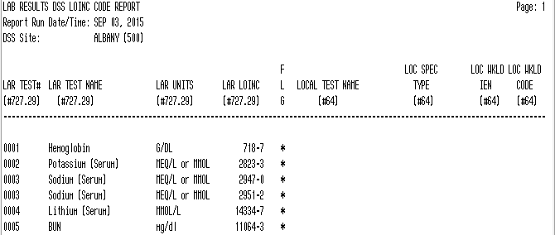
FLG ('*'=site not using LOINC code that DSS collects)

Pharmacy
Choosing the Pharmacy option from the Maintenance Menu will display the following sub-menu and options.
Example: Pharmacy Options Menu
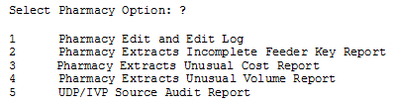

Pharmacy Edit and Edit Log
The option consists of Pharmacy Volume Edit and Pharmacy Volume Edit Log.
NOTE: The ECXPVE security key is required.

Pharmacy Volume Edit
This option allows authorized users to edit the Pharmacy Extracts (PRE, IVP, UDP and BCM). Corrections may be made to the:
- Quantity and Unit of Issue fields for PRE
- Quantity and Total Doses per Day fields for IVP
- Quantity field for UDP
- Component Dose Given and Component Units fields for BCM
NOTE: The extract must be rerun if changes are made after the extract is transmitted. Please contact the MCAO Customer Service Help Desk (CSHD).
NOTE: If a patient’s SSN is entered and a question mark (?) is entered for the extract sequence number, only records including that patient’s SSN will appear in the results.
Example: Pharmacy Volume Edit for PRE
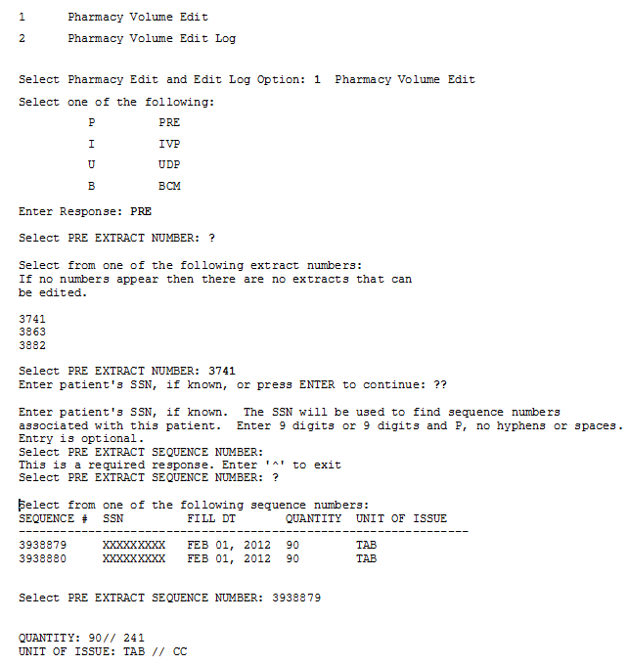
Example: Pharmacy Volume Edit for IVP
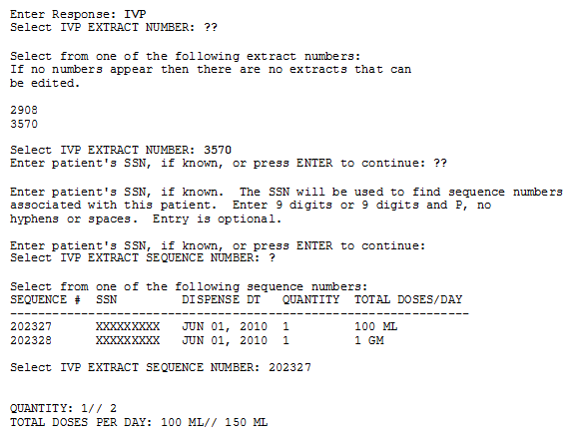
Example: Pharmacy Volume Edit for UDP
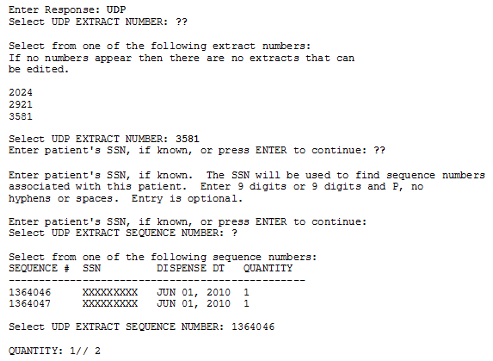
Example: Pharmacy Volume Edit for BCM
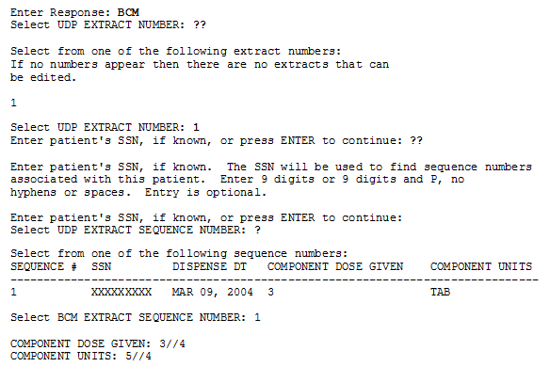

Pharmacy Volume Edit Log
The Pharmacy Volume Edit Log requires a 132-column output. (The sample report was modified to fit into the space below)
Example: Pharmacy Volume Edit Log for PRE
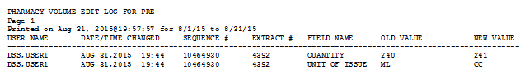
Example: Pharmacy Volume Edit Log for IVP
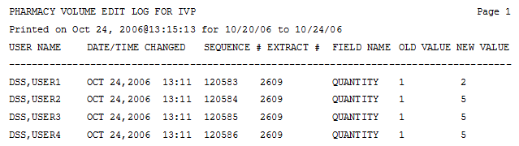
Example: Pharmacy Volume Edit Log for UDP
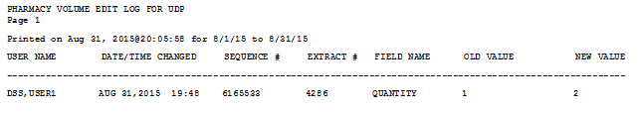
Example: Pharmacy Volume Edit Log for BCM
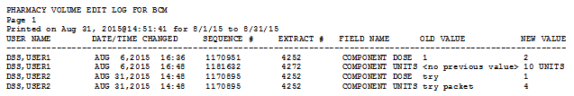

Pharmacy Extracts Incomplete Feeder Key Report
This report prints listing of DRUG file (#50) entries that have incomplete Feeder Keys based on one of the following conditions:
- No PSNDF VA Product Name Entry (first 5 digits are zero)
- No National Drug Code (NDC) (last 12 digits are zero)
- No PSNDF VA Product Name Entry or NDC (all 17 digits are zero)
This report is designed to be run before the extract for a specified date range and can be used as a tool to identify and fix DRUG file (#50) entries that have incomplete Feeder Keys. Only those drugs that would be included on the Extract for the specified date range are listed on the report for the Pharmacy Extract selected (PRE, IVP or UDP). The following columns are included on the report:
- Drug Entry - INTERNAL ENTRY NUMBER (IEN) for the drug from the DRUG file (#50).
- Generic Name - The GENERIC NAME field (#.01) of the drug from the DRUG file (#50).
- Feeder Key - The Feeder Key for the drug, which is the first 5 characters of the PSNDF VA PRODUCT NAME ENTRY field (#22) concatenated with the 12 characters NDC field (#31) from the DRUG file (#50).
- Number of Records - The number of Extract records that would contain this drug for the date range specified if the extract were run.
- Total Quantity - The sum of the quantities of the drug from all of the Extract records. This is the same as the QUANTITY field for the PRE and UDP Extracts. For the IVP Extract the Total Quantity is the sum of the values taken from the ADDITIVE STRENGTH field (#7) or SOLUTION VOLUME field (#9) of the IV EXTRACT DATA file (#728.113).
- Unit Price - The PRICE PER DISPENSE UNIT field (#16) from the DRUG file (#50) for the PRE and UDP Extracts. For the IVP Extract Unit Price is the COST field (#12) of the IV EXTRACT DATA file (#728.113).
- Total Cost - The total cost of the drug for the Extract (Total Quantity x Unit Price). For all three Pharmacy Extracts, the Total Cost is the same as the sum of the COST field from all Extract records containing the drug.
This report requires a 132-column output.
Select Maintenance Option: Pharmacy Extracts Incomplete Feeder Key Report

This report prints a listing of Drug File (#50) entries that will generate incomplete Feeder keys in the three Pharmacy Extracts. This listing can be used to identify and fix Drug File entries. The number of extract records, total, quantity, unit price and total cost for each drug are included to aid in determining the impact of the incomplete Feeder Keys.

This report is broken into 3 sections as follows:

Section 1: No PSNDF VA Product Name Entry (first 5 digits are zero).

Section 2: No National Drug Code (NDC) (last 12 digits are zero) or the NDC is prefixed with an 'S', indicating possible supply item number or UPC.

Section 3: No PSNDF VA Product Name Entry, and a. no NDC (all 17 digits are zero), or b. The NDC is prefixed with an 'S', indicating possible supply item number or UPC. Section 3: No PSNDF VA Product Name Entry or NDC.

Run times for this report will vary depending upon the size of the extract and could take as long as 30 minutes or more to complete. This report has no effect on the actual extracts and can be run as needed.

Example PRE Extracts Incomplete Feeder Key Report
Choose the report you would like to run.

Select one of the following:

1 PRE
2 IVP
3 UDP

Selection: 1// 1 PRE

Enter the date range for which you would like to scan the Prescription
Extract records.
Starting with Date: 2/1 (FEB 01, 2013)
Ending with Date: 2/28 (FEB 28, 2013)

Do you want the output in exportable format? NO// y YES

Gathering data for export...

To ensure all data is captured during the export:

1. Select 'Logging...' from the File Menu. Select your file, and where to save.
2. On the Setup menu, select 'Display...',then 'screen' tab and modify 'columns'
setting to at least 225 characters.
3. The DEVICE input for the columns should also contain a large enough
parameter (e.g. 225). The DEVICE prompt is defaulted to 0;225;99999 for you.
You may change it if need be.
Example: DEVICE: 0;225;99999 *Where 0 is your screen, 225 is the margin width
and 99999 is the screen length.

NOTE: In order for all number fields, such as SSN and Feeder Key, to be
displayed correctly in the spreadsheet, these fields must be formatted as Text
when importing the data into the spreadsheet.

DEVICE: 0;225;99999//
Example: Exported PRE Extracts Incomplete Feeder Key Report
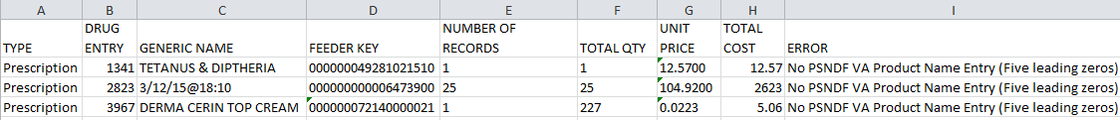
Example: PRE Extracts Incomplete Feeder Key Report Screen Print
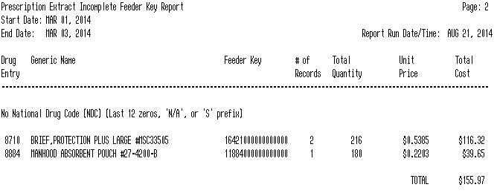

IVP Extracts Incomplete Feeder Key Report
Choose the report you would like to run.

Select one of the following:

1 PRE
2 IVP
3 UDP

Selection: 1// 2 IVP

Enter the date range for which you would like to scan the IV Detail
Extract records.

Starting with Date: 2/1 (FEB 01, 2013)
Ending with Date: 2/28 (FEB 28, 2013)

Do you want the output in exportable format? NO// y YES

Gathering data for export...

To ensure all data is captured during the export:

1. Select 'Logging...' from the File Menu. Select your file, and where to save.
2. On the Setup menu, select 'Display...',then 'screen' tab and modify 'columns'
setting to at least 225 characters.
3. The DEVICE input for the columns should also contain a large enough
parameter (e.g. 225). The DEVICE prompt is defaulted to 0;225;99999 for you.
You may change it if need be.
Example: DEVICE: 0;225;99999 *Where 0 is your screen, 225 is the margin width
and 99999 is the screen length.

NOTE: In order for all number fields, such as SSN and Feeder Key, to be
displayed correctly in the spreadsheet, these fields must be formatted as Text
when importing the data into the spreadsheet.

DEVICE: 0;225;99999//
Example: IVP Extracts Incomplete Feeder Key Report Screen Print
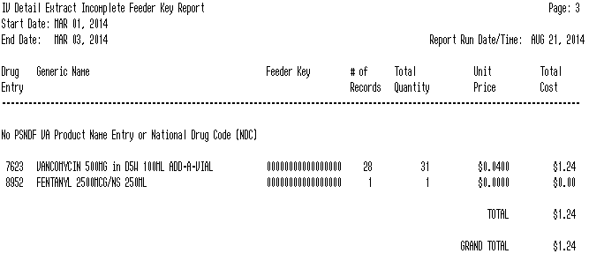

Example: Exported IVP Extracts Incomplete Feeder Key Report

UDP Extracts Incomplete Feeder Key Report
Choose the report you would like to run.

Select one of the following:

1 PRE
2 IVP
3 UDP

Selection: 1// 3 UDP

Enter the date range for which you would like to scan the Unit Dose Local
Extract records.

Starting with Date: 2/1 (FEB 01, 2013)
Ending with Date: 2/28 (FEB 28, 2013)

Do you want the output in exportable format? NO// y YES

Gathering data for export...

To ensure all data is captured during the export:

1. Select 'Logging...' from the File Menu. Select your file, and where to save.
2. On the Setup menu, select 'Display...',then 'screen' tab and modify 'columns'
setting to at least 225 characters.
3. The DEVICE input for the columns should also contain a large enough
parameter (e.g. 225). The DEVICE prompt is defaulted to 0;225;99999 for you.
You may change it if need be.
Example: DEVICE: 0;225;99999 *Where 0 is your screen, 225 is the margin width
and 99999 is the screen length.

NOTE: In order for all number fields, such as SSN and Feeder Key, to be
displayed correctly in the spreadsheet, these fields must be formatted as Text
when importing the data into the spreadsheet.

DEVICE: 0;225;99999//
Example: Exported UDP Extracts Incomplete Feeder Key Report
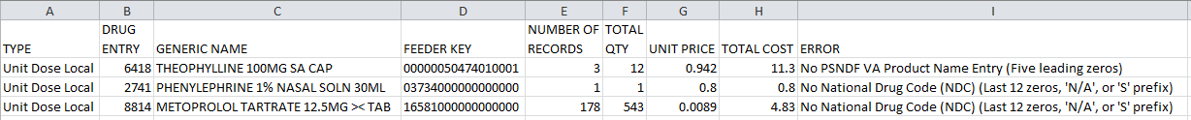
Example: UDP Extracts Incomplete Feeder Key Report Screen Print
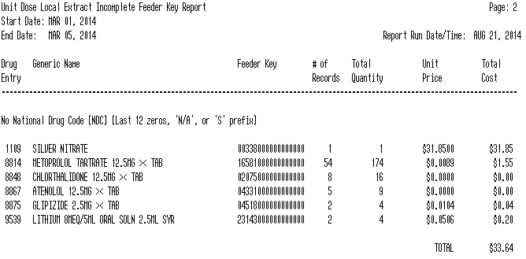

Pharmacy Extracts Unusual Cost Report
Users with the ECXMGR security key can export the data for all reports on the Pharmacy Extracts Unusual Cost Report option into an external spreadsheet. Users also have the option to view the report on the screen.
This report prints a listing of unusual costs that would be generated by the pharmacy extracts (PRE, IVP, and UDP) as determined by a user defined threshold value. It should be run prior to the generation of the actual extract(s) to identify and fix as necessary any costs determined to be erroneous.

Note: The threshold can be set after a report is selected.

Run times for this report will vary depending upon the size of the extract and could take as long as 30 minutes or more to complete. This report has no effect on the actual extracts and can be run as needed.

The report is sorted by Feeder Key, Descending Cost, and SSN.

Enter RETURN to continue or '^' to exit:
Example: Pharmacy Extracts Unusual Cost Report
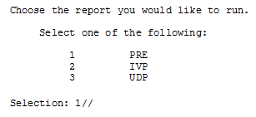

PRE Unusual Cost Report
The default threshold cost for the Prescription extract is $50.
Would you like to change the threshold? NO// n NO

Enter the date range for which you would like to scan the Prescription
Extract records.
Starting with Date: 2/1/12 (FEB 01, 2012)
Ending with Date: 2/28/12 (FEB 28, 2012)

Do you want the output in exportable format? NO// YES

Gathering data for export...

To ensure all data is captured during the export:

1. Select 'Logging...' from the File Menu. Select your file, and where to save.
2. On the Setup menu, select 'Display...',then 'screen' tab and modify 'columns'
setting to at least 225 characters.
3. The DEVICE input for the columns should also contain a large enough
parameter (e.g. 225). The DEVICE prompt is defaulted to 0;225;99999 for you.
You may change it if need be.

Example: DEVICE: 0;225;99999 *Where 0 is your screen, 225 is the margin width
and 99999 is the screen length.

NOTE: In order for all number fields, such as SSN and Feeder Key, to be
displayed correctly in the spreadsheet, these fields must be formatted as Text
when importing the data into the spreadsheet.

DEVICE: 0;225;99999//
Example: Exported PRE Unusual Cost Report
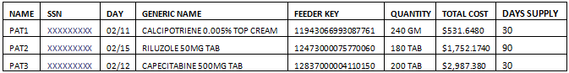
Example: PRE Unusual Cost Report Displayed on Screen
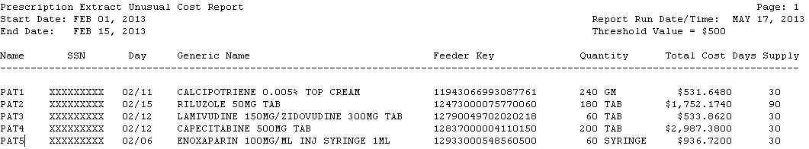

IVP Unusual Cost Report
The default threshold cost for the IV Detail extract is $100.
Would you like to change the threshold? NO// n NO

Enter the date range for which you would like to scan the IV Detail
Extract records.
Starting with Date: 2/1/13 (FEB 01, 2013)
Ending with Date: 2/28/13 (FEB 28, 2013)

Do you want the output in exportable format? NO// y YES

Gathering data for export...

To ensure all data is captured during the export:

1. Select 'Logging...' from the File Menu. Select your file, and where to save.
2. On the Setup menu, select 'Display...',then 'screen' tab and modify 'columns'
setting to at least 225 characters.
3. The DEVICE input for the columns should also contain a large enough
parameter (e.g. 225). The DEVICE prompt is defaulted to 0;225;99999 for you.
You may change it if need be.
Example: DEVICE: 0;225;99999 *Where 0 is your screen, 225 is the margin width
and 99999 is the screen length.

NOTE: In order for all number fields, such as SSN and Feeder Key, to be
displayed correctly in the spreadsheet, these fields must be formatted as Text
when importing the data into the spreadsheet.

DEVICE: 0;225;99999//
Example: Exported IVP Unusual Cost Report
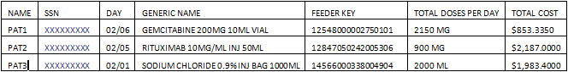
Example: IVP Unusual Cost Report Displayed on Screen
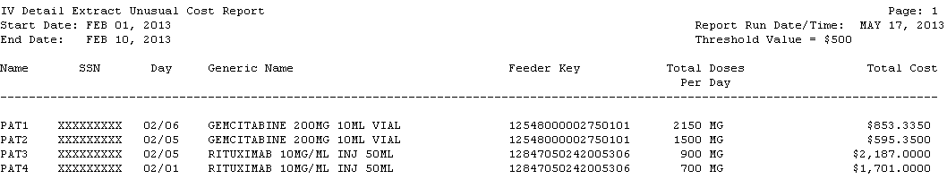

UDP Unusual Cost Report
The default threshold cost for the Unit Dose Local extract is $20.
Would you like to change the threshold? NO// n NO
Include SIG/Order Direction on line 2 of report? NO// n NO

Enter the date range for which you would like to scan the Unit Dose Local
Extract records.
Starting with Date: 5/1/13 (MAY 01, 2013)
Ending with Date: 5/31/13 (MAY 31, 2013)

Do you want the output in exportable format? NO// y YES

Gathering data for export...

To ensure all data is captured during the export:

1. Select 'Logging...' from the File Menu. Select your file, and where to save.
2. On the Setup menu, select 'Display...',then 'screen' tab and modify 'columns'
setting to at least 225 characters.
3. The DEVICE input for the columns should also contain a large enough
parameter (e.g. 225). The DEVICE prompt is defaulted to 0;225;99999 for you.
You may change it if need be.
Example: DEVICE: 0;225;99999 *Where 0 is your screen, 225 is the margin width
and 99999 is the screen length.

NOTE: In order for all number fields, such as SSN and Feeder Key, to be
displayed correctly in the spreadsheet, these fields must be formatted as Text
when importing the data into the spreadsheet.

DEVICE: 0;225;99999//
Example: Exported UDP Unusual Cost Report
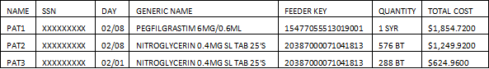
Example: UDP Unusual Cost Report Displayed on Screen
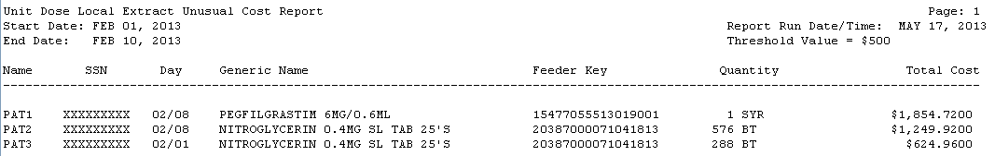

Pharmacy Extracts Unusual Volume Report
This report prints a listing of unusual volumes that would be generated by the pharmacy extracts (PRE, IVP, UDP and BCM) as determined by a user defined threshold value. It should be run prior to the generation of the actual extract(s) to identify and fix as necessary any volumes determined to be erroneous.

Unusual volumes are defined as follows:

PRE Extract: Quantity field greater than the threshold value.
IVP Extract: Total Doses Per Day field greater than the threshold
or less than the negative of the threshold value.
UDP Extract: Quantity field greater than threshold value.
BCM Extract: Component Dose Given field greater than threshold value.

Note: The threshold can be set after a report is selected.

Run times for this report will vary depending upon the size of the extract and could take as long as 30 minutes or more to complete. This report has no effect on the actual extracts and can be run as needed.

The report is sorted by Feeder Key, Descending Volume, and SSN.

Enter RETURN to continue or '^' to exit: <RET>

PRE Unusual Volume Report
Choose the report you would like to run.

Select one of the following:

1 PRE
2 IVP
3 UDP
4 BCM

Selection: 1// 1 PRE

The default threshold volume for the Prescription extract is 500.
Would you like to change the threshold?? NO//

Enter the date range for which you would like to scan the Prescription
Extract records.
Starting with Date: 02012013 (FEB 01, 2013)
Ending with Date: 02282013 (FEB 28, 2013)

Do you want the output in exportable format? NO// Y

Gathering data for export...

To ensure all data is captured during the export:

1. Select 'Logging...' from the File Menu. Select your file, and where to save.
2. On the Setup menu, select 'Display...',then 'screen' tab and modify 'columns'
setting to at least 225 characters.
3. The DEVICE input for the columns should also contain a large enough
parameter (e.g. 225). The DEVICE prompt is defaulted to 0;225;99999 for you.
You may change it if need be.
Example: DEVICE: 0;225;99999 *Where 0 is your screen, 225 is the margin width
and 99999 is the screen length.

NOTE: In order for all number fields, such as SSN and Feeder Key, to be
displayed correctly in the spreadsheet, these fields must be formatted as Text
when importing the data into the spreadsheet.

DEVICE: 0;225;99999//
Example: Export Prescription Extract Unusual Volume Report
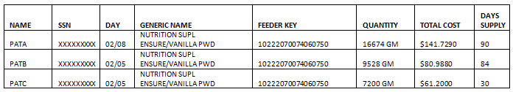
Example: Prescription Extract Unusual Volume Report Displayed on Screen
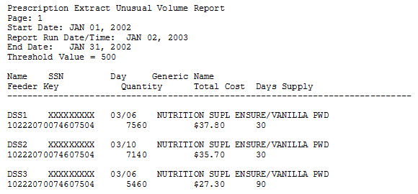

IVP Unusual Volume Report
Choose the report you would like to run.

Select one of the following:

1 PRE
2 IVP
3 UDP
4 BCM

Selection: 1// 2 IVP

The default threshold volume for the IV Detail extract is 1000.
Would you like to change the threshold? NO// n NO

Enter the date range for which you would like to scan the IV Detail
Extract records.
Starting with Date: 02012013 (FEB 01, 2013)
Ending with Date: 02282013 (FEB 28, 2013)

Do you want the output in exportable format? NO// Y

Gathering data for export...

To ensure all data is captured during the export:

1. Select 'Logging...' from the File Menu. Select your file, and where to save.
2. On the Setup menu, select 'Display...',then 'screen' tab and modify 'columns'
setting to at least 225 characters.
3. The DEVICE input for the columns should also contain a large enough
parameter (e.g. 225). The DEVICE prompt is defaulted to 0;225;99999 for you.
You may change it if need be.
Example: DEVICE: 0;225;99999 *Where 0 is your screen, 225 is the margin width
and 99999 is the screen length.

NOTE: In order for all number fields, such as SSN and Feeder Key, to be
displayed correctly in the spreadsheet, these fields must be formatted as Text
when importing the data into the spreadsheet.

DEVICE: 0;225;99999//
Example: Exported IV Detail Extract Unusual Volume Report
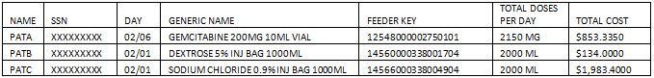
NOTE: The Total Cost column displays 4 decimal places and is calculated by multiplying the Average Drug Cost per U nit by the Total Doses per Day.
Example: IV Detail Extract Unusual Volume Report
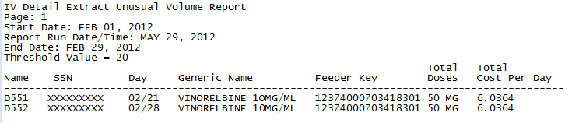

UDP Unusual Volume Report
NOTE: Users can choose to add the SIG/Order Directions on the second line of this report. SIG/Order Direction information is produced by combining Prescription Unit Dose and Schedule information. This field will assist pharmacists that are responsible for audits to distinguish dispensing errors.
Choose the report you would like to run.

Select one of the following:

1 PRE
2 IVP
3 UDP

Selection: 1// 3 UDP

The default threshold volume for the Unit Dose Local extract is 500.
Would you like to change the threshold? NO// Y YES

Quantity > threshold
Enter the new threshold volume: (0-100000): 20
Include SIG/Order Direction on line 2 of report? NO// YES

Enter the date range for which you would like to scan the Unit Dose Local
Extract records.
Starting with Date: February 1, 2012 (FEB 01, 2012)
Ending with Date: February 29, 2012 (FEB 29, 2012)

Do you want the output in exportable format? NO// Y

Gathering data for export...

To ensure all data is captured during the export:

1. Select 'Logging...' from the File Menu. Select your file, and where to save.
2. On the Setup menu, select 'Display...',then 'screen' tab and modify 'columns'
setting to at least 225 characters.
3. The DEVICE input for the columns should also contain a large enough
parameter (e.g. 225). The DEVICE prompt is defaulted to 0;225;99999 for you.
You may change it if need be.
Example: DEVICE: 0;225;99999 *Where 0 is your screen, 225 is the margin width
and 99999 is the screen length.

NOTE: In order for all number fields, such as SSN and Feeder Key, to be
displayed correctly in the spreadsheet, these fields must be formatted as Text
when importing the data into the spreadsheet.

DEVICE: 0;225;99999//
Example: Exported UDP Detail Extract Unusual Volume Report with SIG/Order Directions Added
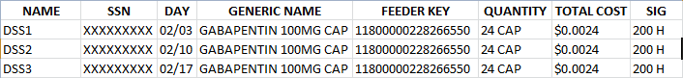
Example: UDP Detail Extract Unusual Volume Report with SIG/Order Directions Added Displayed on Screen
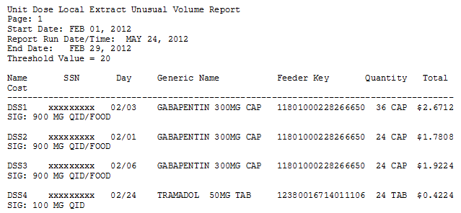
Example: Exported UDP Detail Extract Unusual Volume Report without SIG/Order Directions Added
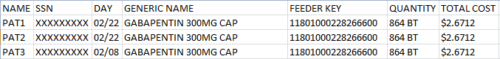
Example: UDP Detail Extract Unusual Volume Report without SIG/Order Directions Added Displayed on Screen
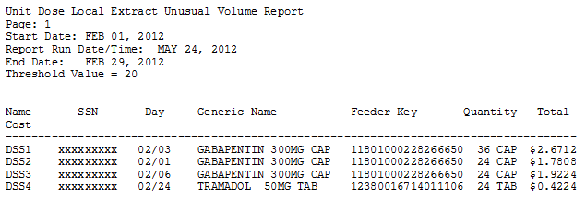
Example: UDP Detail Extract Unusual Volume Report without SIG/Order Directions Added Displayed on Screen
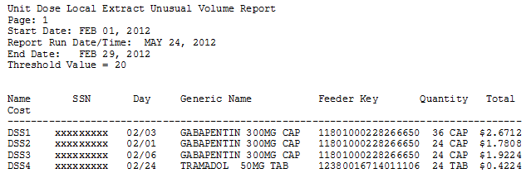

BCM Unusual Volume Report
Choose the report you would like to run.

Select one of the following:

1 PRE
2 IVP
3 UDP
4 BCM

Selection: 1// 4 BCM

Select one of the following:

I IV
N NON-IV

Select type of BCM record: N

The default threshold volume for the BCM-NON IV Entries extract is 5.
Would you like to change the threshold? NO// n NO
Include SIG/Order Direction on line 2 of report? NO// y YES

Enter the date range for which you would like to scan the BCM-NON IV Entries
Extract records.
Starting with Date: 02012013 (FEB 01, 2013)
Ending with Date: 02282013 (FEB 28, 2013)

Do you want the output in exportable format? NO// N
Example: Exported BCM Detail Extract Unusual Volume Report with SIG/Order Directions Added (Non-IV)
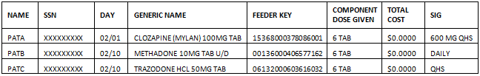
Example: BCM Detail Extract Unusual Volume Report with SIG/Order Directions Added Displayed on Screen (Non-IV)
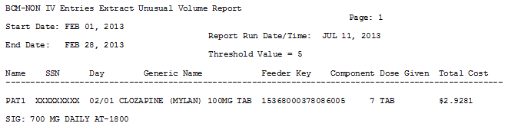
Example: Exported BCM Detail Extract Unusual Volume Report without SIG/Order Directions Added (IV)
Example: BCM Detail Extract Unusual Volume Report without SIG/Order Directions Added Displayed on Screen (IV)
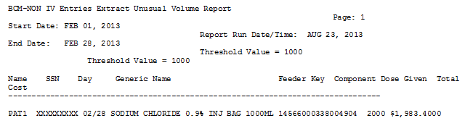

UDP/IVP Source Audit Report
The Source Audit Reports provide a record count for each Division and Date combination chosen. The reports pull information from the UDP and IVP Intermediate source files within the DSS name space: UNIT DOSE EXTRACT DATA file (#728.904) and the IV EXTRACT DATA file (#728.113).
Example: UDP Source Audit Report
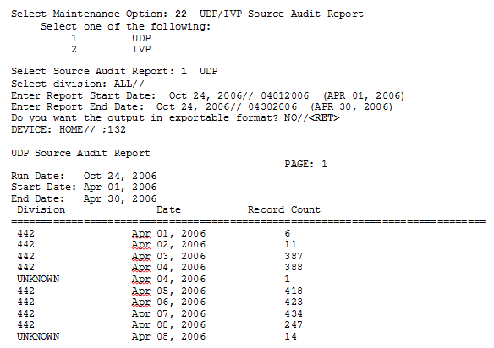
Example: Exported UDP Source Audit Report
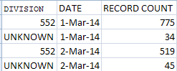
Example: IVP Source Audit Report
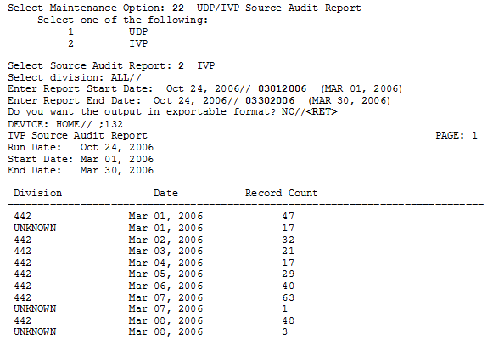
Example: Exported IVP Source Audit Report
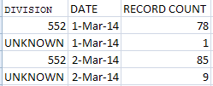

Print Feeder Keys
Refer to Appendix A for information about feeder key transmission.
Use this option to print a list of feeder keys for a selected individual feeder system or a range of feeder systems. For some feeder systems, you will be prompted to select the sort method (old or new). All feeder systems prompt for a device. The output will vary slightly, depending on the version of National Drug File (NDF) your site is running.
Example: Print Feeder Keys
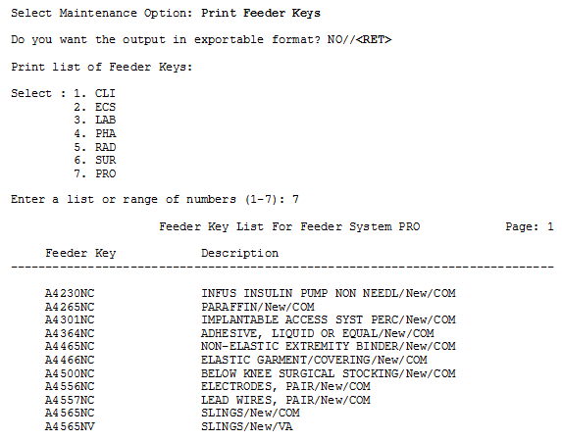
Example: Exported Print Feeder Keys - PRO
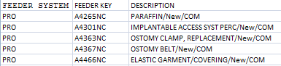

Print Feeder Locations
Use this option to print a list of feeder locations for all feeder systems. The output is sorted by feeder location within each feeder system. This report could be lengthy, so you might want to queue to print during non-peak hours. The only prompt is for a device.
Example: Print List of Feeder Locations
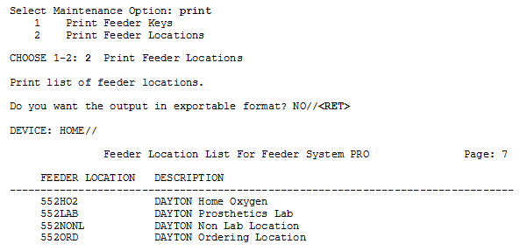
Example: Exported Print List of Feeder Locations
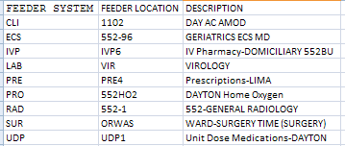
(To save space, only a portion of the above reports and exports are shown)

Prosthetics
Choosing the Prosthetics option from the Maintenance Menu will display the following sub-menu and options.
Example: Prosthetics Menu Options
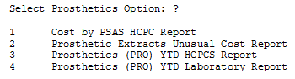

Cost by PSAS HCPC Report
This menu option creates a report named Cost by PSAS HCPC REPORT. The Cost by PSAS HCPC is a prosthetics report that includes expenditures for a given time frame.
The Cost by PSAS HCPC Report consists of the following fields:
- PSAS HCPC - DSS Field (#30)/VistA Field (#32) on PRO extract
- Description (Free text field of 64 characters)
- Form
- QTY
- Unit of issue
- Cost
- Grand Total
- Form Description (included in the exported version only)

Select Prosthetics Option: Cost by PSAS HCPC Report
Enter Report Start Date: 2/1/13 (FEB 01, 2013)
Enter Report Ending Date: (2/1/2013 - 8/26/2013): 2/28/13 (FEB 28, 2013)

Do you want the output in exportable format? NO// y YES

Gathering data for export...

To ensure all data is captured during the export:

1. Select 'Logging...' from the File Menu. Select your file, and where to save.
2. On the Setup menu, select 'Display...',then 'screen' tab and modify 'columns'
setting to at least 225 characters.
3. The DEVICE input for the columns should also contain a large enough
parameter (e.g. 225). The DEVICE prompt is defaulted to 0;225;99999 for you.
You may change it if need be.
Example: DEVICE: 0;225;99999 *Where 0 is your screen, 225 is the margin width
and 99999 is the screen length.

NOTE: In order for all number fields, such as SSN and Feeder Key, to be
displayed correctly in the spreadsheet, these fields must be formatted as Text
when importing the data into the spreadsheet.

DEVICE: 0;225;99999// HOME (CRT)

Example: Exported Cost by PSAS HCPC Report
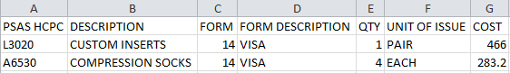
Example: Cost by PSAS HCPC Report Screen Print
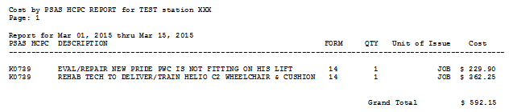

Prosthetic Extracts Unusual Cost Report
Select Prosthetics Option: Prosthetic Extract Unusual Cost Report

This report prints a listing of unusual costs that would be
generated by the Prosthetic extract (PRO) as determined by a
user-defined threshold value. It should be run prior to the
generation of the actual extract(s) to identify and fix, as
necessary, any costs determined to be erroneous.

Unusual costs are those where the Cost of Transaction is
greater than the threshold value.

Note: The threshold can be set after a report is selected.

Run times for this report will vary depending upon the size of
the extract and could take as long as 30 minutes or more to
complete. This report has no effect on the actual extracts and
can be run as needed.

The report is sorted by Feeder Key, then by descending Cost of
Transaction and SSN.

Enter RETURN to continue or '^' to exit:

The default threshold cost for the Prosthetic extract is $500.00.
Would you like to change the threshold?? NO// n NO

Enter the date range for which you would like to scan the Prosthetic
Extract records.

Starting with Date: 2/1 (FEB 01, 2013)
Ending with Date: 2/8 (FEB 08, 2013)

Do you want the output in exportable format? NO// y YES

Gathering data for export...

To ensure all data is captured during the export:

1. Select 'Logging...' from the File Menu. Select your file, and where to save.
2. On the Setup menu, select 'Display...',then 'screen' tab and modify 'columns'
setting to at least 225 characters.
3. The DEVICE input for the columns should also contain a large enough
parameter (e.g. 225). The DEVICE prompt is defaulted to 0;225;99999 for you. You may change it if need be.
Example: DEVICE: 0;225;99999 *Where 0 is your screen, 225 is the margin width
and 99999 is the screen length.

NOTE: In order for all number fields, such as SSN and Feeder Key, to be
displayed correctly in the spreadsheet, these fields must be formatted as Text
when importing the data into the spreadsheet.

DEVICE: 0;225;99999// HOME (CRT)
Exampl90e: Export Prosthetic Extracts Unusual Cost Report
NAME | SSN | DATE OF SERVICE | FORM | FORM DESCRIPTION | PSAS HCPCS CODE | FEEDER KEY | QUANTITY | COST OF TRANSACTION | TRANSACTION TYPE
CHIC | XXXXXXXX | 06/18/14 | 14 | VISA | DL191 | DL191NC | 1 | 1,269.00 | I
Example: Prosthetic Extracts Unusual Cost Report Screen Print
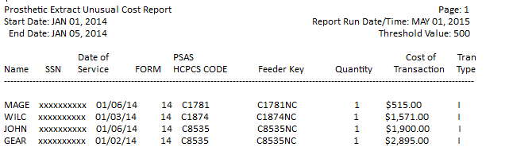

Prosthetics (PRO) YTD HCPCS Report
The Prosthetics YTD HCPCS Report displays data from Prosthetics extracts from the beginning of the fiscal year to the ending date of the last extract. Data from the current or previous fiscal year may be selected for the report. The report is divided into three sections: New (i.e., Initial, Replacement or Spare items), Repairs and Rentals.
Sites that are multidivisional prosthetics sites must specify the Primary Prosthetics Division for the report. The user may then choose to generate a specific report for one division or a combined report for all divisions. The report is sorted by PSAS HCPCS Code. A print device capable of displaying a 132-character line is needed for output.
Setup for PRO Extract YTD HCPCS Report --

If you belong to more than one Primary Division, you must
select a Primary Division for the report.
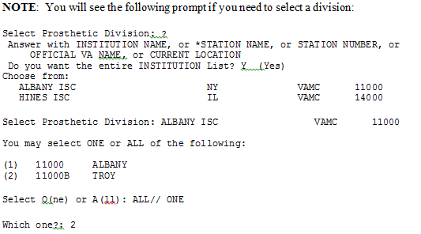
Do you want the output in exportable format? NO// n NO

Select C(urrent) or P(revious) Fiscal Year: CURRENT// c CURRENT

Do you want the output in exportable format? NO// y YES

Gathering data for export...

To ensure all data is captured during the export:

1. Select 'Logging...' from the File Menu. Select your file, and where to save.
2. On the Setup menu, select 'Display...',then 'screen' tab and modify 'columns'
setting to at least 225 characters.
3. The DEVICE input for the columns should also contain a large enough
parameter (e.g. 225). The DEVICE prompt is defaulted to 0;225;99999 for you.
You may change it if need be.
Example: DEVICE: 0;225;99999 *Where 0 is your screen, 225 is the margin width
and 99999 is the screen length.

NOTE: In order for all number fields, such as SSN and Feeder Key, to be
displayed correctly in the spreadsheet, these fields must be formatted as Text
when importing the data into the spreadsheet.

DEVICE: 0;225;99999// HOME (CRT)

Please note: The PRO Extract YTD HCPCS Report requires 132 columns.
Select an appropriate device for output.
Example: Exported PRO Extract YTD HCPCS Report
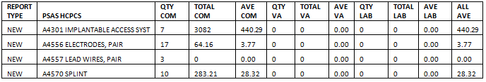
Example: PRO Extract YTD HCPCS Report Screen Print
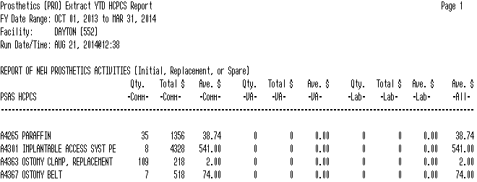
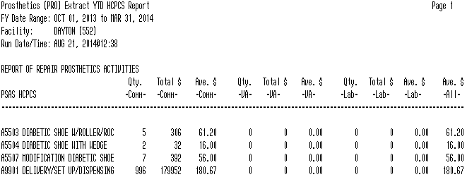
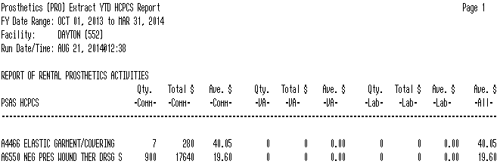

Prosthetics (PRO) YTD Laboratory Report
The Prosthetics YTD Laboratory Report displays data from Prosthetics extracts from the beginning of the fiscal year to the ending date of the last extract. It is intended for use by sites that have on-site prosthetics laboratories. Data from the current or previous fiscal year may be selected for the report. The report is divided into three sections: New (i.e., Initial, Replacement, or Spare items), Repairs and Rentals. Sites that are multidivisional prosthetics sites must specify the Primary Prosthetics Division for the report.
The report is sorted by PSAS HCPCS Code. It shows quantity, labor and material costs for items within each PSAS HCPCS Code. Two sets of totals are displayed on each line: totals for items produced for use at the local site and totals for items produced for other VA stations.
Select Prosthetics Option: Prosthetics (PRO) YTD Laboratory Report

Setup for PRO Extract YTD Laboratory Report --

If you belong to more than one Primary Division, you must
select a Primary Division for the report.

Select C(urrent) or P(revious) Fiscal Year: CURRENT// c CURRENT

Do you want the output in exportable format? NO// y YES

Gathering data for export...

To ensure all data is captured during the export:

1. Select 'Logging...' from the File Menu. Select your file, and where to save.
2. On the Setup menu, select 'Display...',then 'screen' tab and modify 'columns'
setting to at least 225 characters.
3. The DEVICE input for the columns should also contain a large enough
parameter (e.g. 225). The DEVICE prompt is defaulted to 0;225;99999 for you.
You may change it if need be.
Example: DEVICE: 0;225;99999 *Where 0 is your screen, 225 is the margin width
and 99999 is the screen length.

NOTE: In order for all number fields, such as SSN and Feeder Key, to be
displayed correctly in the spreadsheet, these fields must be formatted as Text
when importing the data into the spreadsheet.

DEVICE: 0;225;99999//
Example: Exported PRO Extract YTD Laboratory Report
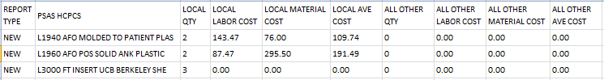
Example: PRO Extract YTD Laboratory Report Screen Print
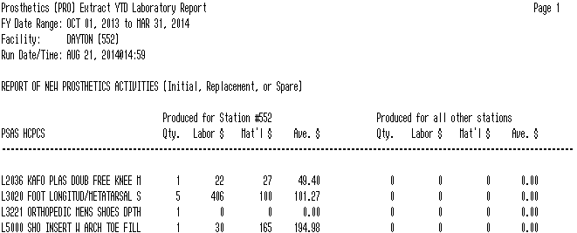
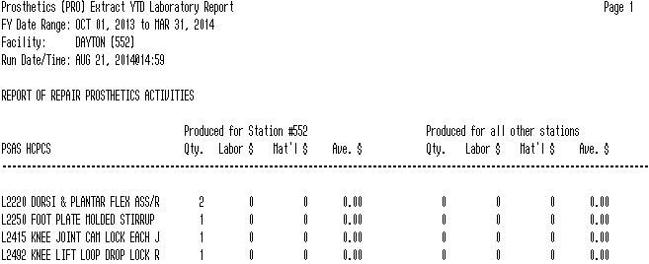

Setup for DSS Clinic Information
Choosing the Setup for DSS Clinic Information option from the Maintenance Menu will display the following sub-menu and options.
Example: DSS Clinic Information Menu Options
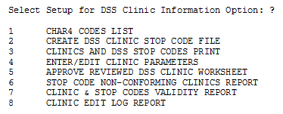

CHAR4 Codes List
Use this option to print a list of the CHAR4 codes with short descriptions from the NATIONAL CLINIC file (#728.441). The only prompt is for a device. You might want to use the output generated by this option as a reference guide when using the following options:
- Approve Reviewed DSS Clinic Worksheet
- Enter/Edit DSS Stop Codes For Clinics
- Clinics And DSS Stop Codes Print
- Create DSS Clinic Stop Code File
Example: CHAR4 Codes List
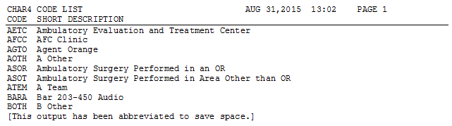
Example: Exported CHAR4 Codes List
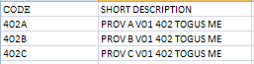

Create DSS Clinic Stop Code File
- You can run this option at any time to add new clinics created by MAS.
- Running this option does not affect existing data in the CLINICS AND STOP CODES file (#728.44). This file includes the RECORD LAST SYNCHED field that holds the last date that the Create DSS Clinic Stop Code File option was run.
- It is recommended that this option be run on a monthly basis. The suggested time is prior to generating the Clinic Visit Extract.
Use this option to create local entries in the CLINICS AND STOP CODES file (#728.44).
Select Setup for DSS Clinic Information Option: 2 Create DSS Clinic Stop Code File

This option creates local entries in the DSS CLINIC AND STOP CODES
file (#728.44).

The CREATE option last ran on 8/27/13.

Do you want to run the CREATE option? N// y YES

Running CREATE..................................................................

The CREATE option has completed on Aug 28, 2013@09:11:17.

Proceed to DSS Clinic and Stop Code Print menu? NO// y YES

This option produces a worksheet of (A) All Clinics, (C) Active, (D) Duplicate, (I) Inactive, or only the (U) Unreviewed Clinics that are awaiting approval.

Clinics that were defined as "inactive" by MAS the last time the option
"Create DSS Clinic Stop Code File" was run will be indicated with an "*".

Choose (X) for exporting the CLINICS AND STOP CODES FILE to a text file for
spreadsheet use.

**REMINDER - The CREATE option last ran on 8/28/13.
If the most recent clinic changes from the HOSPITAL LOCATION file #44
are desired, run the CREATE option before running a report.**

Select one of the following:

A ALL CLINICS
C ALL ACTIVE CLINICS
D DUPLICATE CLINICS
I ALL INACTIVE CLINICS
U UNREVIEWED CLINICS
X EXPORT TO TEXT FILE FOR SPREADSHEET USE

Enter "A", "C", “D”, "I", "U", or "X":
The software uses the following logic to create entries in the CLINICS AND STOP CODES file (#728.44).

New Clinic Entries
The software searches the HOSPITAL LOCATION file (#44) for all clinics. It does not create entries for clinics that are currently inactive.
New clinic entries are added to the CLINICS AND STOP CODES file (#728.44) with the following field defaults.
Field # | Field Name | Default value
1 | STOP CODE | STOP CODE NUMBER field (#8) in the HOSPITAL LOCATION file (#44)
2 | CREDIT STOP CODE | CREDIT STOP CODE field (#2503) in HOSPITAL LOCATION file (#44)
3 | DSS STOP CODE | STOP CODE NUMBER field (#8) in HOSPITAL LOCATION file (#44)
4 | DSS CREDIT STOP CODE | CREDIT STOP CODE field (#2503) in HOSPITAL LOCATION file (#44)
5 | ACTION TO SEND | 1: SEND STOP CODE  4: SEND BOTH AS ONE RECORD WITH CHAR4 CODE  5: SEND BOTH AS ONE RECORD WITHOUT CHAR4 CODE  6: DO NOT SEND

Existing Clinic Entries
All preexisting clinics are checked against their counterparts in the HOSPITAL LOCATION file (#44) to be sure that the STOP CODE field (#1) in the CLINICS AND STOP CODES file (#728.44) matches the STOP CODE NUMBER field (#8) in the HOSPITAL LOCATION file (#44). The same check is made on the CREDIT STOP CODE field (#2) to be sure that it matches the CREDIT STOP CODE field (#2503) in the HOSPITAL LOCATION file (#44).
Any preexisting clinic that is currently marked as inactive in the HOSPITAL LOCATION file (#44) is flagged as inactive in the CLINICS AND STOP CODES file (#728.44). This inactive indicator will be displayed as an asterisk (*) beside the clinic name on the worksheet generated by the Clinics and DSS Stop Codes Print option. Inactive clinics may still have valid past data for DSS.
Any Stop Code changes to preexisting clinics will delete the “Last Approved” date in the CLINICS AND STOP CODES file (#728.44). This will ensure that the edited clinics print out as “Unreviewed” the next time the clinic worksheet is generated using the Clinics and DSS Stop Codes Print option.

Clinics and DSS Stop Codes Print
Use this option to produce the Worksheet for DSS Clinic Stops showing one of the following:
- All Clinic Stops
- Active Clinic Stops
- Duplicate Clinic Stops
- Inactive Clinic Stops
- Unreviewed Clinic Stops
A clinic will be reported as “Unreviewed” if it is newly established or if there is a change to Stop Code/Credit Stop, Count/Non-Count clinic status or Active/Inactive clinic status.
The columns included on the spreadsheet are:
- IEN
- Clinic
- Stop Code
- Credit Stop Code
- Action
- Last Approved Date
- CHAR4 Code
- Inact Date
- React Date
- Clinic Type
- App Len
- Div
- App Type
- Non Cnt
- Occasion of Service (OOS)
- OOS Calling Pkg
- Var Length Appt
- DSS Prod Dept
Columns listed in the Worksheet for DSS Clinic Stops printed from the screen include:
- Last approved date
- Print Date
- Clinic (followed by * if inactive)
- Stop Code
- Credit Stop Code
- Action
- CHAR4 Code
- C/N
Column “C / N” on the printed report and column “Non Cnt” on the export report, captures changes to a clinic’s Count / Non Count status. Values in the column will be “C” for count or “N” for non-count on the printed report and “YES” or “NO” on the exported report.
The clinic name is truncated so there is at least one space between the clinic name and stop code columns on the printed report.
Clinics that are inactive have an asterisk “*” after the clinic name on the printed reports only. On the exported reports, the date the clinic was inactivated is shown. (Note: if an inactive clinic was reactivated the reactivation date is shown.)
Select Setup for DSS Clinic Information Option: 3 Clinics and DSS Stop Codes Print

This option produces a worksheet of (A) All Clinics, (C) Active, (D) Duplicate,
(I) Inactive, or only the (U) Unreviewed Clinics that are awaiting approval.

Clinics that were defined as "inactive" by MAS the last time the option
"Create DSS Clinic Stop Code File" was run will be indicated with an "*".

Choose (X) for exporting the CLINICS AND STOP CODES FILE to a text file for
spreadsheet use.

**REMINDER - The CREATE option last ran on 8/28/13.
If the most recent clinic changes from the HOSPITAL LOCATION file #44
are desired, run the CREATE option before running a report.**

Select one of the following:

A ALL CLINICS
C ALL ACTIVE CLINICS
D DUPLICATE CLINICS
I ALL INACTIVE CLINICS
U UNREVIEWED CLINICS
X EXPORT TO TEXT FILE FOR SPREADSHEET USE

Example All Clinics Option
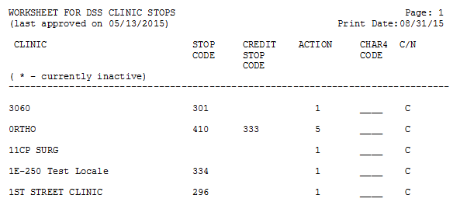

Example All Active Clinics Option
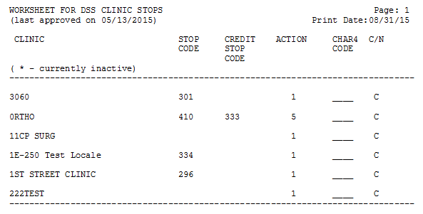

Example Duplicate Clinics Option
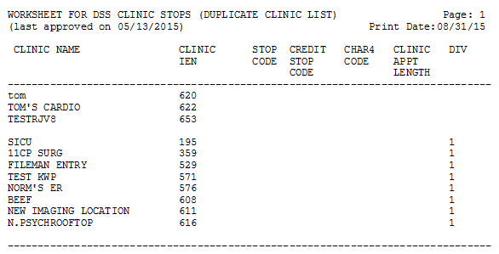

Example All Inactive Clinics Option
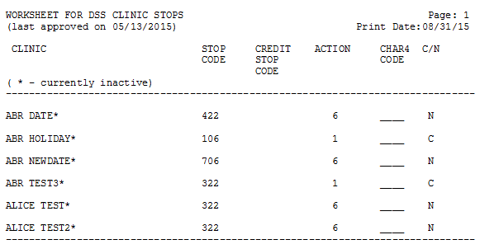

Example Unreviewed Clinics Option
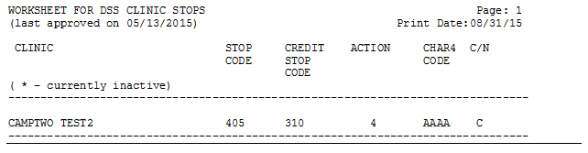

Export Clinic Review Report Option
Select Setup for DSS Clinic Information Option: Clinics and DSS Stop Codes Print

Choose (X) for exporting the CLINICS AND STOP CODES FILE to a text file for
spreadsheet use.

Select one of the following:

A ALL CLINICS
C ALL ACTIVE CLINICS
D DUPLICATE CLINICS
I ALL INACTIVE CLINICS
U UNREVIEWED CLINICS
X EXPORT TO TEXT FILE FOR SPREADSHEET USE

Enter "A", "C", "D", "I", "U", or "X": X EXPORT TO TEXT FILE FOR SPREADSHEET USE

Select which clinics to include on the spreadsheet for exporting.
Select (A)ll, a(C)tive, (D)uplicate, (I)nactive,
or (U)nreviewed clinics for export: ALL CLINICS

Gathering data for export...

To ensure all data is captured during the export:

1. Select 'Logging...' from the File Menu. Select your file, and where to save.
2. On the Setup menu, select 'Display...',then 'screen' tab and modify 'columns'
setting to at least 225 characters.
3. The DEVICE input for the columns should also contain a large enough
parameter (e.g. 225). The DEVICE prompt is defaulted to 0;225;99999 for you.
You may change it if need be.
Example: DEVICE: 0;225;99999 *Where 0 is your screen, 225 is the margin width
and 99999 is the screen length.

NOTE: In order for all number fields, such as SSN and Feeder Key, to be
displayed correctly in the spreadsheet, these fields must be formatted as Text
when importing the data into the spreadsheet.

DEVICE: 0;225;99999//

NOTE: For clinics that are inactive, the date they were inactivated is listed. If an Inactive Clinic was reactivated, the Reactivation Date is listed.
Example: Exported All Clinics Spreadsheet
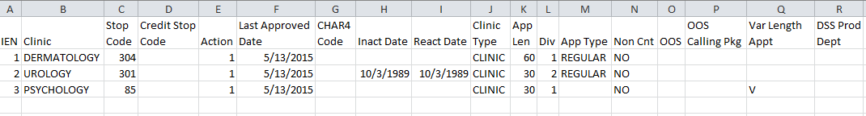
Example: Exported All Active Clinics Spreadsheet
Example: Exported Duplicate Clinics Spreadsheet
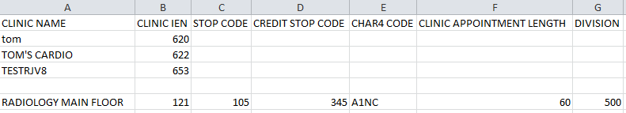
Example: Exported All Inactive Clinics Spreadsheet
Example: Exported Unreviewed Clinics Spreadsheet

Enter/Edit Clinic Parameters
Use this option to enter or edit the ACTION TO SEND codes and other parameters associated with each clinic for the DSS extract.
The option to select how the Stop Codes and/or Credit Stop Codes are sent can be changed. The default is set to SEND BOTH AS ONE RECORD WITH CHAR4 CODE, unless it is a NON-COUNT clinic, in which case the default will be DO NOT SEND. The example below shows the options that are available.
Modifying the DSS PRODUCT DEPARTMENT information will not cause a clinic to become “Unreviewed”.
Example: Action to Send Description and Menu Choices
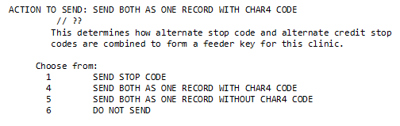
Through prompts, there is the option to add or edit the CHAR4 Code, DSS Unit Identifier and DSS Product Department.
Example: Enter/Edit Clinic Parameters
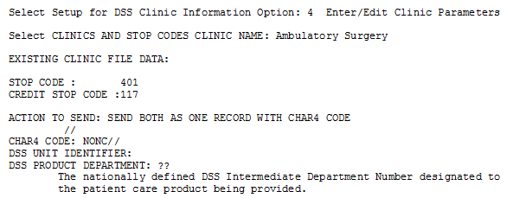

Approve Reviewed DSS Clinic Worksheet
Use this option to approve all Stop Codes and Credit Stop Codes as defined in the CLINICS AND STOP CODES file (#728.44) and to mark all currently existing entries in this file as reviewed.
Example: Clinics and Stop Code File
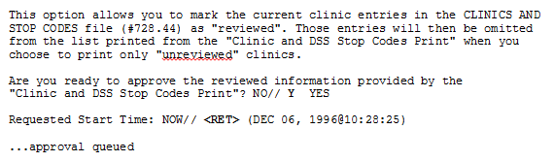

Stop Code Non-Conforming Clinics Report
Stop Codes are assigned a restriction type of primary, secondary or either. Primary types can only be used in the primary stop code position; secondary types can only be used in the secondary stop code position; and those with a type of either can be used in the primary or secondary stop code position. Stop Codes that have a restriction type of primary or secondary will also have a restriction date to track when the Stop Code is designated as restricted. Clinics are validated to insure that Stop Codes are in compliance with restriction types.
The Stop Code Non-Conforming Clinics Report option is used to print or export a listing of the clinics that do not conform to the Stop Code and Four Character Code (CHAR4) restriction types. Clinics in the Clinics and Stop Code file (#728.44) are also included on the report when they contain the following:
- A Stop Code is inactive or has an inactive date in the future
- A Credit Stop Code is inactive or has an inactive date in the future
- CHAR4 Code is inactive
NOTE: CHAR4 Codes cannot be added, deleted or modified by users.
You may choose to print or export the report for active clinics, inactive clinics, or both. The report will list the Internal Entry Number (IEN), clinic name, Stop Code, Credit Stop Code, CHAR4 Code, and the reason for non-conformance.

If all the selected clinics conform to the Stop Code and Four Character Codes restriction types, "No problem clinics found" is displayed on the report. If necessary, you may use the Enter/Edit Clinic Parameters option to make corrections to the problem clinics.

This option reviews the Primary and Secondary Stop Codes and any existing Four
Character Codes in the Clinics and Stop Codes file #728.44.
It produces a report highlighting any nonconformance reasons that pertain
to the Primary and Secondary Codes, or the Four Character Codes if present.
Please contact the responsible party for corrective action.

Stop Code Non-Conforming Active Clinics Report
Select one of the following:

A Active Clinics
I Inactive Clinics
B Both

Select Report: a Active Clinics
Please be patient, this may take a few moments...
Do you want the output in exportable format? NO//

Gathering data for export...

To ensure all data is captured during the export:

1. Select 'Logging...' from the File Menu. Select your file, and where to save.
2. On the Setup menu, select 'Display...',then 'screen' tab and modify 'columns'
setting to at least 225 characters.
3. The DEVICE input for the columns should also contain a large enough
parameter (e.g. 225). The DEVICE prompt is defaulted to 0;225;99999 for you.
You may change it if need be.
Example: DEVICE: 0;225;99999 *Where 0 is your screen, 225 is the margin width
and 99999 is the screen length.

NOTE: In order for all number fields, such as SSN and Feeder Key, to be
displayed correctly in the spreadsheet, these fields must be formatted as Text
when importing the data into the spreadsheet.

DEVICE: 0;225;99999//
Example: Exported Stop Code Non-Conforming Clinics Report – Active
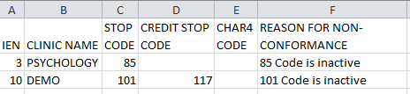
Example: Screen Print of Stop Code Non-Conforming Clinics Report - Active
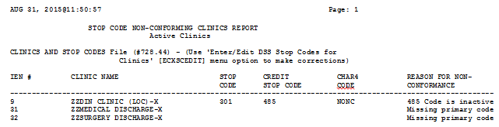

Stop Code Non-Conforming Inactive Clinics
Select one of the following:

A Active Clinics
I Inactive Clinics
B Both

Select Report: i Inactive Clinics
Please be patient, this may take a few moments...

Do you want the output in exportable format? NO// y YES

Gathering data for export...

To ensure all data is captured during the export:

1. Select 'Logging...' from the File Menu. Select your file, and where to save.
2. On the Setup menu, select 'Display...',then 'screen' tab and modify 'columns'
setting to at least 225 characters.
3. The DEVICE input for the columns should also contain a large enough
parameter (e.g. 225). The DEVICE prompt is defaulted to 0;225;99999 for you.
You may change it if need be.
Example: DEVICE: 0;225;99999 *Where 0 is your screen, 225 is the margin width
and 99999 is the screen length.

NOTE: In order for all number fields, such as SSN and Feeder Key, to be
displayed correctly in the spreadsheet, these fields must be formatted as Text
when importing the data into the spreadsheet.

DEVICE: 0;225;99999//
Example: Exported Stop Code Non-Conforming Clinics Report – Inactive
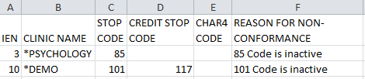
NOTE: The asterisk (*) before the clinic name denotes an Inactive Clinic.
Example: Screen Print of Stop Code Non-Conforming Clinics Report - Inactive
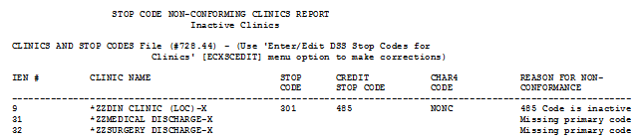
NOTE: The asterisk (*) before the clinic name denotes an Inactive Clinic.

Stop Code Non-Conforming Both Active and Inactive Clinics
Select one of the following:

A Active Clinics
I Inactive Clinics
B Both

Select Report: b Both
Please be patient, this may take a few moments...

Do you want the output in exportable format? NO// y YES

Gathering data for export...

To ensure all data is captured during the export:

1. Select 'Logging...' from the File Menu. Select your file, and where to save.
2. On the Setup menu, select 'Display...',then 'screen' tab and modify 'columns'
setting to at least 225 characters.
3. The DEVICE input for the columns should also contain a large enough
parameter (e.g. 225). The DEVICE prompt is defaulted to 0;225;99999 for you.
You may change it if need be.
Example: DEVICE: 0;225;99999 *Where 0 is your screen, 225 is the margin width
and 99999 is the screen length.

NOTE: In order for all number fields, such as SSN and Feeder Key, to be
displayed correctly in the spreadsheet, these fields must be formatted as Text
when importing the data into the spreadsheet.

DEVICE: 0;225;99999//
Example: Exported Stop Code Non-Conforming Clinics Report – Both Active and Inactive
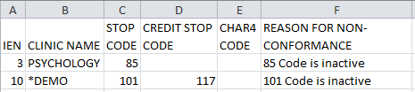
NOTE: The asterisk (*) before the clinic name denotes an Inactive Clinic.
Example: Screen Print of Stop Code Non-Conforming Clinics Report - Both Active and Inactive
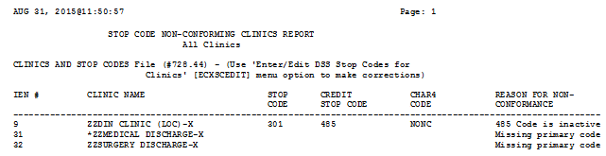
NOTE: The asterisk (*) before the clinic name denotes an Inactive Clinic.

Clinic and Stop Codes Validity Report
The Clinic & Stop Codes Validity Report is used to identify clinic setups that have become invalid due to changes that have occurred with Stop Codes or Credit Stop Codes subsequent to initial clinic setup.
The clinic’s Stop Codes must be active, valid and conform to the restriction types. If any of the following six conditions are not met, the clinic will be listed on the report with a descriptive message explaining what needs to be updated.
- Must be active
- Must be three numeric characters in length and be valid
- Must be in the correct position for the restriction type
- Must not have matching codes
- Must not have an inactive date in the future
- Must not have an inactive CHAR4 Code

NOTE: CHAR4 Codes cannot be added, deleted or modified by users.
Select Setup for DSS Clinic Information Option: Clinic & Stop Codes Validity Report

This report will display stop code information of the ACTIVE
clinics in the Clinics and Stop Code file (#728.44). It will
display stop codes that do not conform to the Business Rules for
Valid Stop Codes.

Do you want the output in exportable format? NO// y YES

Gathering data for export...

To ensure all data is captured during the export:

Gathering data for export...

To ensure all data is captured during the export:

1. Select 'Logging...' from the File Menu. Select your file, and where to save.
2. On the Setup menu, select 'Display...',then 'screen' tab and modify 'columns'
setting to at least 225 characters.
3. The DEVICE input for the columns should also contain a large enough
parameter (e.g. 225). The DEVICE prompt is defaulted to 0;225;99999 for you.
You may change it if need be.
Example: DEVICE: 0;225;99999 *Where 0 is your screen, 225 is the margin width
and 99999 is the screen length.

NOTE: In order for all number fields, such as SSN and Feeder Key, to be
displayed correctly in the spreadsheet, these fields must be formatted as Text
when importing the data into the spreadsheet.

DEVICE: 0;225;99999//

Example: Exported Clinic and Stop Codes Validity Report

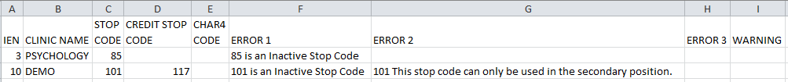
Example: Clinic and Stop Codes Validity Report
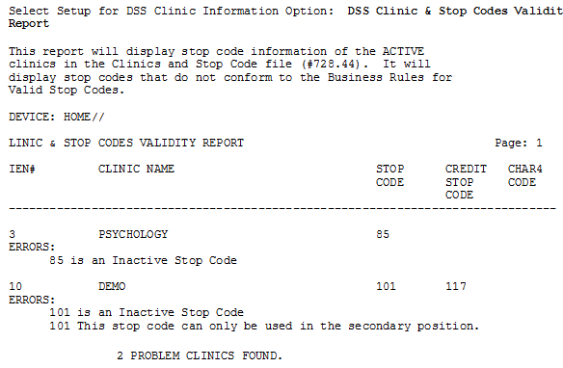

Clinic Edit Log Report
This option prints a log of changes made to Clinic Locations. The user will select one of the following:
1 USER NAME
2 DATE CHANGED
Example: Clinic Edit Log Report
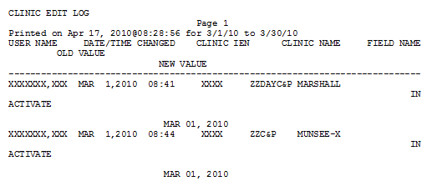
Example: Exported Clinic Edit log Report
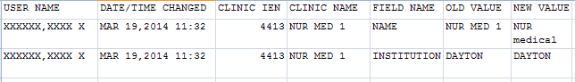

Setup for Inpatient Census Information
Choosing the Setup for Inpatient Census Information option from the Maintenance Menu will display the following sub-menu and options.
Example: Patient Census Information Menu Options
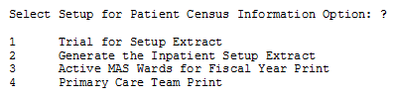

Trial for Setup Extract
Use this option to generate a printed report of the inpatient population on a selected date. The report is sorted by inpatient ward. Within each ward, the data is sorted by patient name, SSN and admit date. You can compare this report to reports from MAS to eliminate any problems in the ADMISSION SETUP EXTRACT file (#727.82).
Example: Inpatient Population Report on a Selected Date
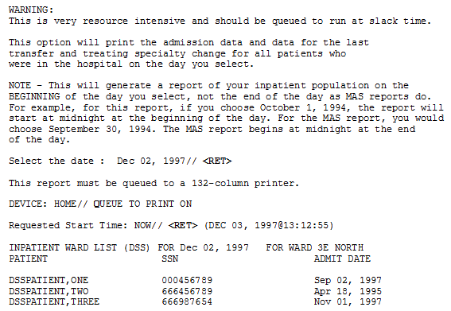

Generate the Inpatient Setup Extract
Your site should run this option only if your site has never sent any DSS Extract data to AITC to initialize the setup extract files listed below. Once this is accomplished, the option should not be used again.
Use this option to generate the Inpatient Setup Extract, which creates the hospital population for the selected DSS start date. This data is stored in the following files until it is transmitted to AITC.
ADMISSION SETUP EXTRACT file (#727.82)
PHYSICAL MOVEMENT SETUP EXTRACT file (#727.821)
TREATING SPECIALTY CHANGE SETUP EXTRACT file (#727.822)
Example: Inpatient Setup Extract
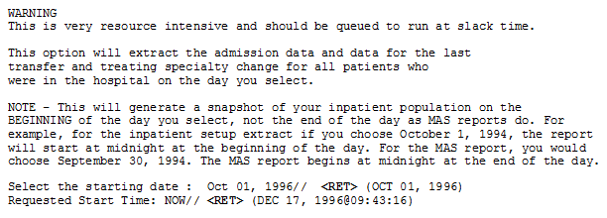

Active MAS Wards for Fiscal Year Print
This option is intended to provide help for building wards in the commercial database at AITC.
Use this option to print a list of all MAS wards that were active at any time during the current fiscal year. The only prompt is for a device. The output is formatted for 132 columns. It is sorted by Medical Center Division and displays the following information:
- Pointer to the HOSPITAL LOCATION file (#44)
- Service and specialty associated with the ward in the WARD LOCATION file (#42)
- DSS Product Department associated with the ward in the DSS WARD file (#727.4)

Example: Active MAS Wards for Fiscal Year Print
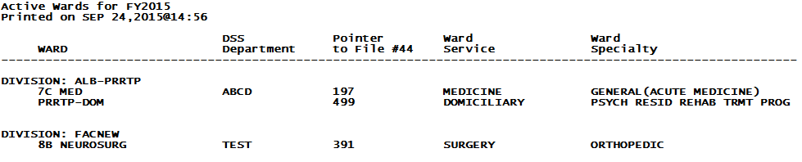

Example: Exported Active MAS Wards for Fiscal Year Print
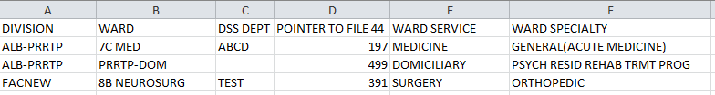

Primary Care Team Print
Use this option to print a list of all primary care teams. The list is sorted alphabetically by team name and displays the pointer to the TEAM file (#404.51). The intent of this option is to provide help for building primary care teams on the commercial DSS system.
Example: Primary Care Team Print
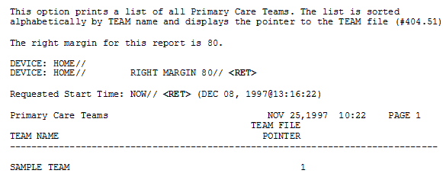
Example: Exported Primary Care Team Print
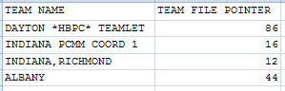

Setup for Inpatient Medications Information
Choosing the Setup for Inpatient Medications Information option from the Maintenance Menu will display the following sub-menu and options.
Example: Inpatient Medications Information Option
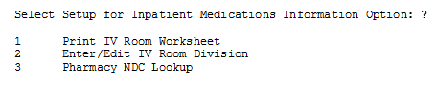

Print IV Room Worksheet
Use this option to print a worksheet listing all the entries in the IV ROOM file (#59.5) of the Inpatient Medications package. This worksheet is intended to be used by the MCA Manager to define the DIVISION (as a pointer to the MEDICAL CENTER DIVISION file [#40.8]) for each IV room for MCA purposes. The report can be displayed normally to the screen or in exported format.
Example: IV Room Worksheet
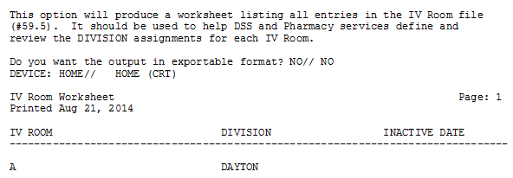
Example: Exported IV Room Worksheet
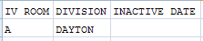

Enter/Edit IV Room Division
Use this option to create or edit entries in the DIVISION field (#.02) of the IV ROOM file (#59.5). The purpose of the DIVISION field is to provide a way to tie outpatient IV data to a medical center division for MCA purposes.
Example: Option for Editing Room Division
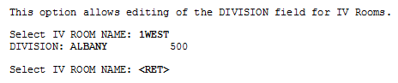

Pharmacy NDC Lookup
Refer to Appendix A for information about feeder key transmission.
Use this option to perform lookups on the local DRUG file (#50) for NDCs from DSS Pharmacy Feeder Keys that have been rejected because the first seven characters are zeros (e.g., "0000000051079014120"). This would occur when a pharmacy item has not been matched to the National Drug File (NDF).
The software prompts you to enter the NDC (last twelve characters) from a rejected feeder key to display the following information from the local DRUG file (#50) for any drug which has that NDC.
- Local Generic Name
- NDC
- Dispense Unit
- VA Classification
- Price Per Dispense Unit
The output will vary slightly, depending on the version of NDF running at your site, as indicated in the following example:
Example: Pharmacy NDC Lookup
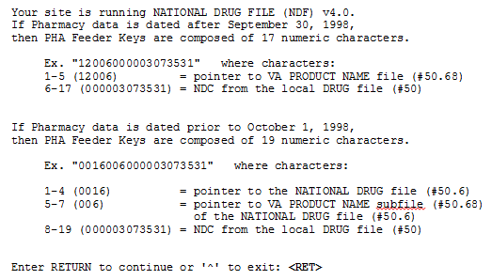
This option will allow lookups on the local DRUG file (#50) using NDCs from DSS Pharmacy Feeder Keys that have been rejected because the first five characters are zeros in a 17-character Feeder Key. (Ex. "00000051079014120") OR the first seven characters are zeros in a 19-character Feeder Key. (Ex. "0000000051079014120")
This would occur when a pharmacy item has not been matched to the National Drug File (NDF).
Enter the NDC (last twelve characters) from a rejected feeder key to display information from the local DRUG file for any drug which has that NDC.
Example: Selecting a NDC
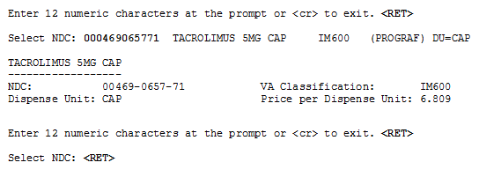

Surgery
Choosing the Surgery option from the Maintenance Menu will display the following sub-menu and options.
Example: Surgery Menu Options
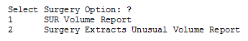

SUR Volume Report
This menu option creates a report that lists all surgical cases that would be generated to the Surgery Extract for transmission to the AITC for review.
Example: SUR Volume Report
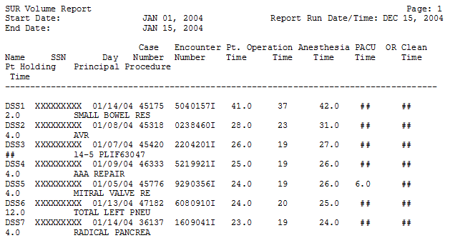
Example: Exported SUR Volume Report
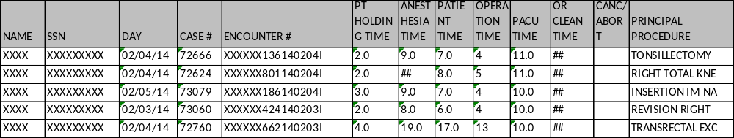

Surgery Extract Unusual Volume Report
The Surgery Extract Unusual Volume Report prints a listing of high hourly volume surgery cases. The report prints a listing of unusual volumes that would be generated by the Surgery Extract as determined by a user-defined threshold value. This report should be run prior to running the Surgery extract. The unusual volumes to be provided in the report are defined by the Operation Time, Patient Time, Anesthesia Time, Recovery Room Time, OR Clean Time and Pt Holding Time fields, any of which may have a value greater than the defined threshold value. The default threshold volume is 25 which equates to 6 hours. The report is sorted by descending Volume and Case Number.
The Surgery Extract Unusual Volume Report will now print records if a time segment is missing.
Example: Surgery Extract Unusual Volume Report
This report prints a listing of unusual volumes that would be
generated by the Surgery extract (SUR) as determined by a
user-defined threshold value. It should be run prior to the
generation of the actual extract(s) to identify and fix, as
necessary, any volumes determined to be erroneous.

Unusual volumes are those where either the Operation Time,
Patient Time, Anesthesia Time, Recovery Room Time, OR Clean Time
or Pt Holding Time field is greater than the threshold value.

Note: The threshold can be set after a report is selected.

Run times for this report will vary depending upon the size of
the extract and could take as long as 30 minutes or more to
complete. This report has no effect on the actual extracts and
can be run as needed.

The report is sorted by descending Volume and Case Number.

Enter RETURN to continue or '^' to exit:

The default threshold volume for the Surgery extract is 25.
The default threshold volume (25) equates to 6 hours.
Would you like to change the threshold?? NO// YES

Volume > threshold

Enter the new threshold volume: (0-99): 5
Enter the date range for which you would like to scan the
Surgery Extract records.

Starting with Date: 03012014 (MAR 01, 2014)
Ending with Date: 03082014 (MAR 08, 2014)
This report requires 132-column format.
DEVICE: HOME// ;132;
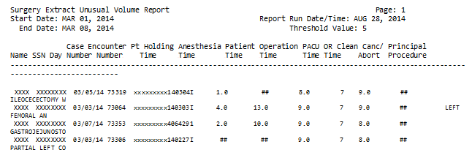
Example: Exported Surgery Extract Unusual Volume Report

Package Extracts
Please refer to the current DSS Extracts v3.0 Data Definitions Guide and Extract File Formats Manual for more information about the record layout for the extracted fields.
The Package Extracts Option was modified so that users with the Security Key ECXMGR may rerun an extract without Information Resources Management (IRM) assistance. The user can reschedule an extract to run again when it has already been scheduled to run, rerun an extract that was previously run, or cancel an extract that is (already) currently running and set it up to run again. Use caution (and read the information being provided to you) when rerunning an extract as it would be possible to have multiples of the same extract running simultaneously.
Example: Prompt for Rerunning an Extract
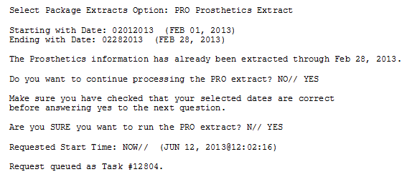
Choosing the Package Extracts option from the Extract Managers Menu will display the following menu and options.
NOTE: The DSS application will remove tildes (~) from extract record data prior to transmitting them in order to avoid sending extract record data that would be recognized as an end-of-record indicator to the AITC, except where the end-of-record is intended.
Example: Package Extracts Options on Extract Managers Menu
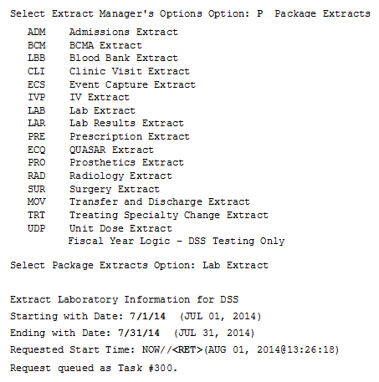

Admissions Extract (ADM)
Use this option to extract the patient admissions data for a selected date range. This data is stored in the ADMISSION EXTRACT file (#727.802) until it is transmitted to AITC.
The mail group for this extract is DSS-ADMS. The purpose of this mail group is to receive messages when the extract is complete and when the data is transmitted to the AITC.

BCMA Extract (BCM)
Use this option to extract data for a selected date range. This data is stored in the BCMA EXTRACT file (#727.833) until it is transmitted to AITC.
The mail group for this extract is DSS-BCM. The purpose of this mail group is to receive messages when the extract is complete and when the data is transmitted to the AITC.

Clinic Visit Extract (CLI)
Use this option to extract data for all scheduled clinic visits, add/edits and walk-ins for the selected date range, with the following exceptions.
Non-Count clinics are excluded unless specifically assigned a DSS Action Code other than 6.
Canceled clinic appointments are excluded. Clinics with an ACTION TO SEND code of 6 in CLINICS AND STOP CODES file (#728.44) are excluded.
This data is stored in the CLINIC EXTRACT file (#727.827) until it is transmitted to AITC.
The mail group for this extract is DSS-SCX. The purpose of this mail group is to receive messages when the extract is complete and when the data is transmitted to the AITC.

Event Capture Local Extract (ECS)
Use this option to extract the event capture data for a selected date range. This data is stored in the EVENT CAPTURE LOCAL EXTRACT file (#727.815) until it is transmitted to AITC.
The mail group for this extract is DSS-EC. The purpose of this mail group is to receive messages when the extract is complete and when the data is transmitted to the AITC.

IV Extract (IVP)
Use this option to extract the pharmacy IV data for a selected date range. This data is stored in the IV DETAIL EXTRACT file (#727.819) until it is transmitted to AITC.
The mail group for this extract is DSS-IV. The purpose of this mail group is to receive messages when the extract is complete and when the data is transmitted to the AITC.

Lab Extract (LAB)
Use this option to extract the laboratory data, including referrals and research tests, for a selected date range. This data is stored in the LABORATORY EXTRACT file (#727.813) until it is transmitted to AITC.
All inpatient, outpatient and referral lab tests accessioned within the selected date range are extracted. Lab tests can be performed on a patient in the PATIENT file (#2) or a referral patient in the REFERRAL PATIENT file (#67). The identifying number is the SSN for in-house patients or a selected non-SSN ID constant for referrals and research.
The mail group for this extract is DSS-LAB. The purpose of this mail group is to receive messages when the extract is complete and when the data is transmitted to the AITC.

Lab Results Extract (LAR)
Use this option to extract the laboratory results data for a selected date range. This data is stored in the LAB RESULTS EXTRACT file (#727.824) until it is transmitted to AITC.
The mail group for this extract is DSS-LAB. The purpose of this mail group is to receive messages when the extract is complete and when the data is transmitted to the AITC.

Prescription Extract (PRE)
Use this option to extract the prescription (pharmacy outpatient) data for a selected date range. This data is stored in the PRESCRIPTION EXTRACT file (#727.81) until it is transmitted to AITC.
The mail group for this extract is DSS-PRES. The purpose of this mail group is to receive messages when the extract is complete and when the data is transmitted to the AITC.

Quasar Extract (ECQ)
Use this option to extract Audiology and Speech Pathology clinic visit data for a selected date range. This data is stored in the QUASAR EXTRACT (#727.825) file until it is transmitted to AITC.
The mail group for this extract is DSS-QSR. The purpose of this mail group is to receive messages when the extract is complete and when the data is transmitted to the AITC.

Prosthetics Extract (PRO)
Use this option to extract the prosthetics data for a selected date range. The data is stored in the PROSTHETICS EXTRACT file (#727.826) until it is transmitted to AITC.
The following information is required to extract a prosthetics record.
- Station Requesting Station
- Patient Name (in Prosthetics)
- SSN
- Receiving Station
- Name (in PATIENT file (#2))
- Type of Transaction
- Delivery Date
- Source
- HCPS
For prosthetics records that could not be extracted, you will receive a Prosthetics DSS Exception message indicating the record IEN in the record of pros appliance/repair file (#660) and the critical information that is missing.
The records identified in this message were not extracted and should be reviewed to determine if they must be corrected and the extract regenerated to assure proper DSS credit is received.
If you are extracting data for a division, you can only select a primary division (as defined for your entries in the PROSTHETICS SITE PARAMETERS file (#669.9) and the NEW PERSON file (#200)).
The mail group for this extract is DSS-PRO. The purpose of this mail group is to receive messages when the extract is complete and when the data is transmitted to the AITC.

Radiology Extract (RAD)
Use this option to extract the radiology data for a selected date range. This data is stored in the RADIOLOGY EXTRACT file (#727.814) until it is transmitted to AITC.
The mail group for this extract is DSS-RAD. The purpose of this mail group is to receive messages when extract is complete and when the data is transmitted to the AITC.

Surgery Extract (SUR)
Use this option to extract the surgery data for a selected date range. This data is stored in the SURGERY EXTRACT file (#727.811) until it is transmitted to AITC. Secondary procedures and prostheses are also extracted.
The mail group for this extract is DSS-SURG. The purpose of this mail group is to receive messages when the extract is complete and when the data is transmitted to the AITC.

Transfer and Discharge Extract (MOV)
Use this option to extract all patient movement (transfers and discharge) data for the selected date range. This data is stored in the PHYSICAL MOVEMENT EXTRACT file (#727.808) until it is transmitted to AITC.
The mail group for this extract is DSS-MOVS. The purpose of this mail group is to receive messages when the extract is complete and when the data is transmitted to the AITC.

Treating Specialty Change Extract (TRT)
Use this option to extract treating specialty change data for a selected date range. This data is stored in the TREATING SPECIALTY CHANGE EXTRACT file (#727.817) until it is transmitted to AITC.
The mail group for this extract is DSS-TREAT. The purpose of this mail group is to receive messages when the extract is complete and when the data is transmitted to the AITC.

Unit Dose Extract (UDP)
Use this option to extract all unit dose orders for the selected date range. Data is extracted from the UNIT DOSE EXTRACT DATA file (#728.904) which is populated by the Inpatient Medications package when a pick list is filed. This data is stored in the UNIT DOSE LOCAL EXTRACT file (#727.809) until it is transmitted to AITC.
The mail group for this extract is DSS-UD. The purpose of this mail group is to receive messages when the extract is complete and when the data is transmitted to the AITC.

Blood Bank Extract (LBB)
Use this option to extract blood bank data for a selected date range. This data is stored in the BLOOD BANK EXTRACT file (#727.829) until the data is transmitted to AITC. This extract enables MCA staff to see and manage the true economic costs of blood product use in the Veterans Health Administration (VHA).
The mail group for this extract is DSS-LBB. The purpose of this mail group is to receive messages when the extract is complete and when the data is transmitted to the AITC.

Fiscal Year Logic – DSS Testing Only
The Fiscal Year Logic - DSS Testing Only option allows selection of a fiscal year that may not have the DSS logic implemented for that year. If a future year (e.g. 2016) is entered and the user does not have the ECX DSS TEST security key, the software does not allow selection of a future fiscal year.
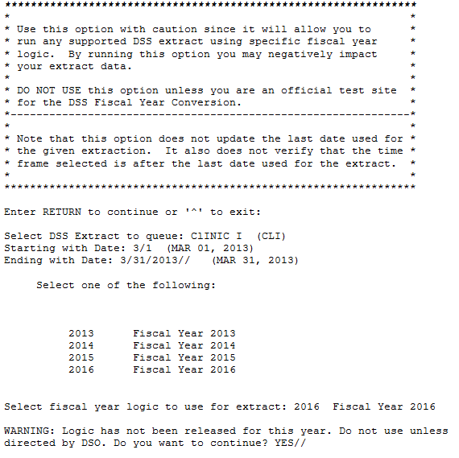

SAS Extract Audit Reports
This section contains a brief description followed by a sample output for each SAS Extract Audit Reports option. To execute any of the SAS Extract Audit Reports options, enter the DSS Extract Log Record Number and a printer device. Please note that in an effort to streamline the documentation, only a portion of the output might be provided for some reports.
Please refer to the Current DSS Extracts Data Definitions Guide and Extract File Formats Manual for more information about the record layout for the extracted fields.

SAS Extracts Audit Reports Menu
Choosing the SAS Extracts Audit Reports option from the Extract Managers Menu will display the following menu and options.
Example: SAS Extract Audit Reports Menu on Extract Managers Menu
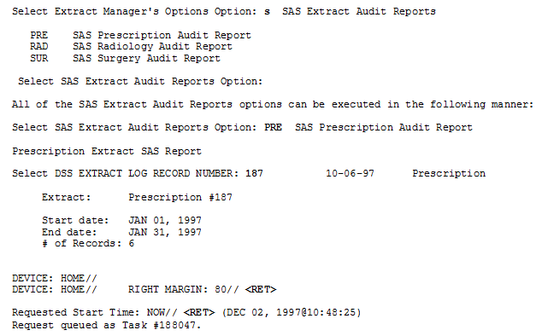

SAS Prescription Audit Report
This option emulates the SAS routine at the AITC, which creates new records from the Prescription (pharmacy outpatient) Extract. You can use it to print a summary report for all records sorted by feeder location and feeder key.
Refer to Appendix A for information about feeder key transmission.
Example: SAS Audit Report for Prescription (PRE) Extract
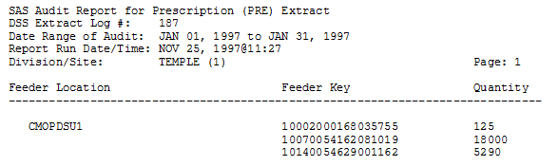
Example: Exported SAS Audit Report for Prescription (PRE) Extract
EXTRACT LOG # | DIVISION/SITE | FEEDER LOCATION | FEEDER KEY | QUANTITY
4733 | TEMPLE(1) | CMOPDSU1 | 10002000168035755 | 225
4733 | TEMPLE(1) | CMOPDSU1 | 10070054162081019 | 18000
4733 | TEMPLE(1) | CMOPDSU1 | 10140054629001162 | 5290

SAS Radiology Audit Report
This option emulates the SAS routine at the AITC, which creates new records from the radiology extract. You may use it to print a summary report for all records sorted by feeder location and feeder key. Note that bilateral modifiers will increase volumes.
Refer to Appendix A for information about feeder key transmission.
Example: SAS Audit Report for Radiology (RAD) Extract
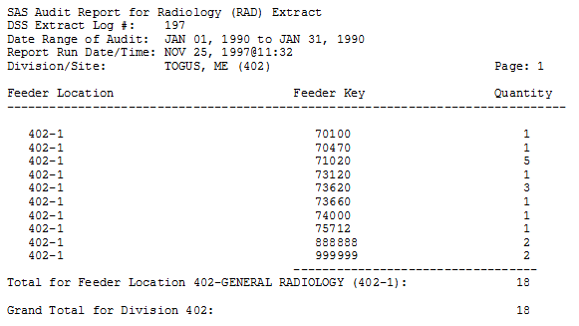
Example: Exported SAS Audit Report for Radiology (RAD) Extract
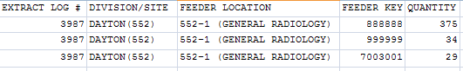

SAS Surgery Audit Report
This option emulates the SAS routine at the AITC, which creates new records from the surgery extract. You can use it to print a summary report for all records sorted by feeder location and feeder key.
Refer to Appendix A for information about feeder key transmission.
Example: SAS Audit Report for Surgery (SUR) Extract
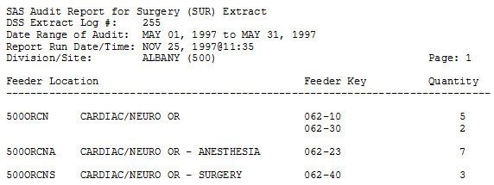
Example: Exported SAS Audit Report for Surgery (SUR) Extract
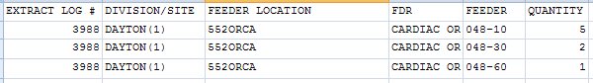

Extract Audit Reports
This section contains a brief description followed by a sample output for each Extract Audit Reports option. To execute any of the Extract Audit Reports options, enter the DSS Extract Log Record Number, starting and ending dates, divisions, locations, or accession areas (as appropriate), and a printer device. There is also a narrative portion of each report that prints only if the report is sent to a printer device. The format of the narrative is the same for all extract audit reports, but the content will vary for each report. Please note that in an effort to streamline the documentation, only a portion of the output might be provided for some reports.
Please refer to the current DSS Extracts Version 3.0 Data Definitions Guide for more information about the record layout for the extracted fields.

Extract Audit Reports Menu
Choosing the Extract Audit Reports option from the Extract Managers Menu will display the following menu and options.
Example: Extract Audit Reports Menu on Extract Managers Menu
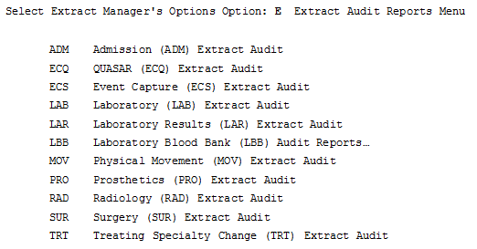
The following dialog for the Admission (ADM) Extract Audit Report is typical of all the audit reports and is provided as an example.
Example: Setup for ADM Extract Audit Report
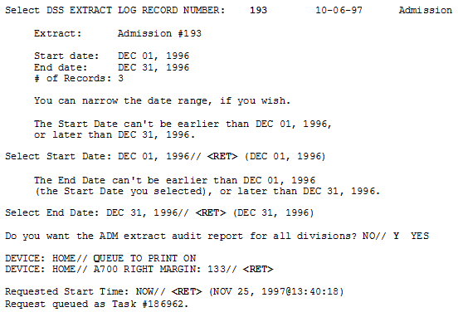
Example: Admission (ADM) Extract Audit Report
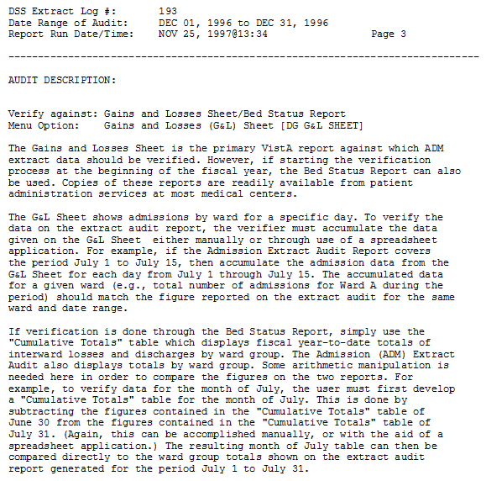

Admission (ADM) Extract Audit
Use this option to print a summary report from the ADMISSION EXTRACT file (#727.802) that displays the number of patient admissions by ward and ward group.
Example: Admission Extract Audit Report
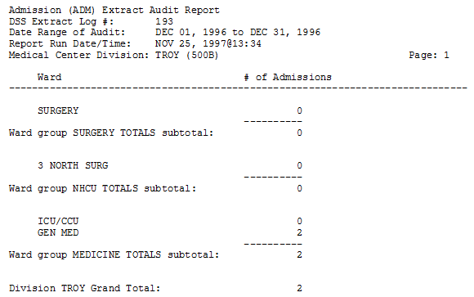
Example: Exported Admission Extract Audit Report
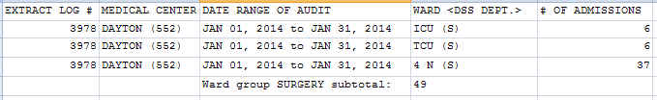

QUASAR (ECQ) Audit
Use this option to print a report from the QUASAR EXTRACT file (#727.825) file. The report displays the number of procedures performed for patient visits to Audiology and Speech Pathology.
Example: QUASAR Extract Audit Report
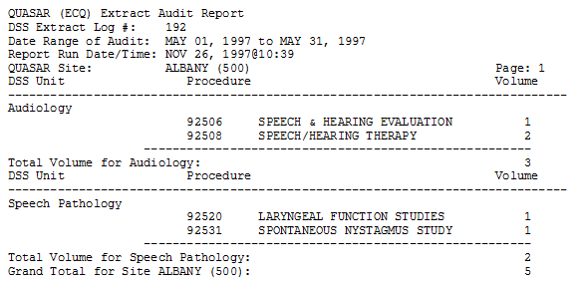
Example: Exported QUASAR Extract Audit Report
EXTRACT LOG # | QUASAR SITE | DIVISION | DSS UNIT | PROCEDURE | PROCEDURE DESCRIPTION | VOLUME
4727 | CENTRAL TEXAS HCS (674) | AUSTIN (674BY) | Audiology | 69210 | REMOVE IMPACTED EAR WAX UNI | 50
4727 | CENTRAL TEXAS HCS (674) | AUSTIN (674BY) | Audiology | 92540 | BASIC VESTIBULAR EVALUATION | 2
 |  |  |  | Volume for Audiology |  | 1605
4727 | CENTRAL TEXAS HCS (674) | AUSTIN (674BY) | Speech Pathology | 92507 | SPEECH/HEARING THERAPY | 26
4727 | CENTRAL TEXAS HCS (674) | AUSTIN (674BY) | Speech Pathology | 92522 | EVALUATE SPEECH PRODUCTION | 2
4727 | CENTRAL TEXAS HCS (674) | AUSTIN (674BY) | Speech Pathology | V5363 | LANGUAGE SCREENING | 1
 |  |  |  | Volume for Speech Pathology |  | 38

Event Capture Local (ECS) Extract Audit
Use this option to print a summary report from the EVENT CAPTURE LOCAL EXTRACT file (#727.815) that displays the number of procedures performed within each DSS Unit.
Select Extract Audit Reports Menu Option: ECS Event Capture (ECS) Extract Audit

Setup for ECS Extract Audit Report --

Select DSS EXTRACT LOG RECORD NUMBER: 3846 04-24-13 Event Capture

Extract: Event Capture #3846

Start date: MAR 01, 2013
End date: MAR 31, 2013
# of Records: 25554

The extract which you have chosen to audit
was transmitted to Austin/DSS on MAY 07, 2013.

Do you want to continue with this audit report? NO// y YES

You can narrow the date range, if you wish.

The Start Date can't be earlier than MAR 01, 2013,
or later than MAR 31, 2013.

Select Start Date: MAR 01, 2013// <RET> (MAR 01, 2013)

The End Date can't be earlier than MAR 01, 2013
(the Start Date you selected), or later than MAR 31, 2013.

Select End Date: MAR 31, 2013// <RET> (MAR 31, 2013)

Do you want the ECS extract audit report for all Locations? NO// y YES

Do you want the output in exportable format? NO// y YES

Gathering data for export...

To ensure all data is captured during the export:

1. Select 'Logging...' from the File Menu. Select your file, and where to save.
2. On the Setup menu, select 'Display...',then 'screen' tab and modify 'columns'
setting to at least 225 characters.
3. The DEVICE input for the columns should also contain a large enough
parameter (e.g. 225). The DEVICE prompt is defaulted to 0;225;99999 for you.
You may change it if need be.
Example: DEVICE: 0;225;99999 *Where 0 is your screen, 225 is the margin width
and 99999 is the screen length.

NOTE: In order for all number fields, such as SSN and Feeder Key, to be
displayed correctly in the spreadsheet, these fields must be formatted as Text
when importing the data into the spreadsheet.

DEVICE: 0;225;99999//
Example: Exported ECS Extract Audit Report
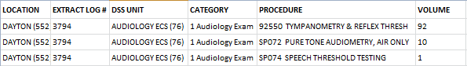
Example: ECS Extract Audit Report Screen Print
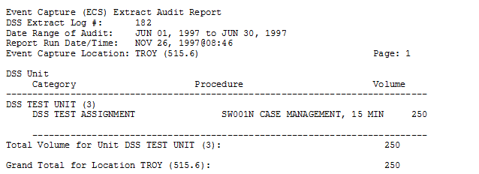
Example: Exported ECS Extract Audit Report Screen Print
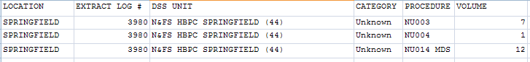

Laboratory (LAB) Extract Audit
Use this option to print a summary report from the LABORATORY EXTRACT file (#727.813) that displays the volume of tests performed within each laboratory accession area.
Example: Laboratory Extract Audit Report
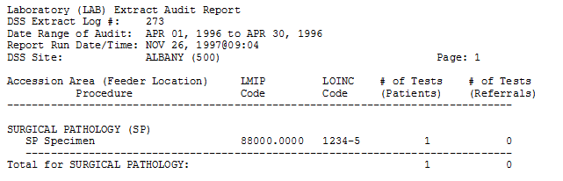
Example: Exported Laboratory Extract Audit Report
EXTRACT LOG # | DSS SITE | ACCESSION AREA (FEEDER LOCATION) | PROCEDURE | LMIP CODE | # OF TESTS (PATIENTS) | # OF TESTS (REFERRALS)
4065 | DAYTON (552) | ANCILLARY (ANC) | Base Excess~DSS ACC | 81246.9999 | 1 | 0
4065 | DAYTON (552) | ANCILLARY (ANC) | Bicarbonate~DSS ACC | 81216.9999 | 1 | 0
4065 | DAYTON (552) | ANCILLARY (ANC) | Chloride~DSS ACC | 82435.9999 | 10 | 0
4065 | DAYTON (552) | ANCILLARY (ANC) | Creatinine~DSS ACC | 82565.9999 | 10 | 0
4065 | DAYTON (552) | ANCILLARY (ANC) | Glucose POC~DSS ACC | 82115.9999 | 1124 | 0

Laboratory Results (LAR) Extract Audit
DSS collects 94 unique LAR tests. The DSS LAR Test Number range from 0001 to 0095 (NOTE: 0012 is missing). “Not in extract” will display in the Total Count column if there has been no workload for a particular DSS LAR test.
Example: Laboratory Results Extract Audit Report (report abbreviated to save space)
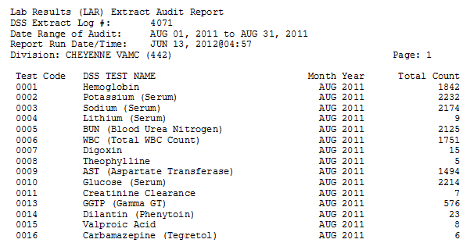
Example: Exported Laboratory Results Extract Audit Report
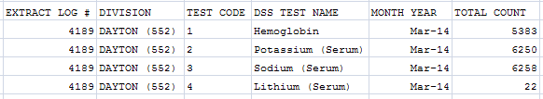

Laboratory Blood Bank (LBB) Audit Reports
There are two reports to choose from under the LBB Audit Reports. The LBB Comparative Report can be run after the extract has run. The LBB Pre-Extract Audit Report, however, can only be run prior to the extract which causes some sites to bypass this audit. If a discrepancy exists, sites can correct the data and run the extract again prior to transmitting the data to AITC.
Example: LBB Audit Reports
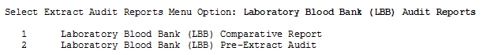

Laboratory Blood Bank (LBB) Comparative Report
Select Laboratory Blood Bank (LBB) Audit Reports Option: Laboratory Blood Bank (LBB) Comparative Report

Setup for LBB Extract Audit Comparative Report…

Select DSS EXTRACT LOG RECORD NUMBER: 2587 06-15-09 Blood Bank
Extract: Blood Bank #2587

Start date: MAR 01, 2009
End date: MAR 31, 2009
# of Records: 139

You can narrow the date range, if you wish.

The Start Date can't be earlier than MAR 01, 2009,
or later than MAR 31, 2009.

Select Start Date: MAR 01, 2009// (MAR 01, 2009)

The End Date can't be earlier than MAR 01, 2009
(the Start Date you selected), or later than MAR 31, 2009.

Select End Date: MAR 31, 2009// (MAR 31, 2009)
Do you want the LBB extract comparative report to sort by COMP? NO// YES

Do you want the output in exportable format? NO// NO

This report requires a print width of 132 characters.
DEVICE: HOME//
Example: LBB Extract Comparative Audit Report
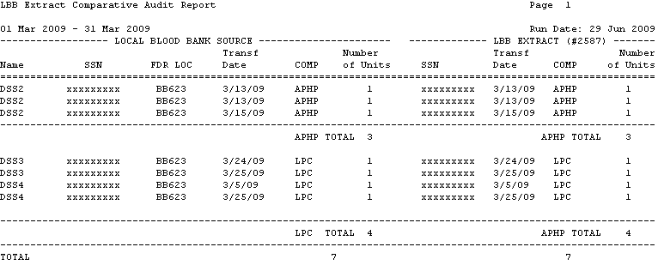
Example: Exported Extract Comparative Audit Report
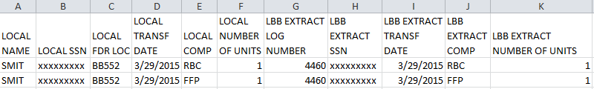

Laboratory Blood Bank (LBB) Pre-Extract Audit
This report provides MCA staff with a list of Blood Bank records that will be included on the LBB extract. The MCA staff should collaborate with the Laboratory Blood Bank staff to review and correct the data as needed, prior to the generation of the LBB extract.
Example: LBB Pre-Extract Audit Report
Select Extract Audit Reports Menu Option: LBB Laboratory Blood Bank (LBB) Audit Reports

Laboratory Blood Bank (LBB) Comparative Report
Laboratory Blood Bank (LBB) Pre-Extract Audit

Select Laboratory Blood Bank (LBB) Audit Reports Option: 2 Laboratory Blood Bank (LBB) Pre-Extract Audits

LBB Pre-Extract Audit Report Information for DSS

**NOTE: This audit can only be run prior to the LBB Extract being generated.
If you have already generated your LBB Extract, refer to the Processing
Guide Chapter 4 section on Regenerating.**

Starting with Date: 2/1/2012 (FEB 01, 2012)
Ending with Date: 2/29/2012 (FEB 29, 2012)

Previously, you have selected queuing.
Do you STILL want your output QUEUED? Yes// N (No)
DEVICE: HOME// Right Margin: 80//

Retrieving records...

LBB Extract Audit Report Page 1
01 Feb 2012 - 29 Feb 2012 Run Date: 07 Jan 2012
Transf Number
Name SSN FDR LOC Date COMP of Units
==============================================================================
DSSA 000054102 BB523A4 2/6/12 LRB3 1
DSSA 000054102 BB523A4 2/6/12 LRB3 1
DSSB 000224430 BB523A4 2/21/12 LRB3 1
DSSC 000403825 BB523A4 2/16/12 LRB3 1
DSSC 000403825 BB523A4 2/13/12 LPAX 1
DSSC 000403825 BB523A4 2/12/12 LPAX 1
DSSC 000403825 BB523A4 2/12/12 CR-P 10
Example: Exported LBB Pre-Extract Audit Report
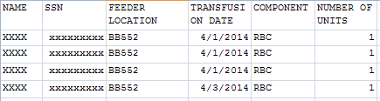

Physical Movement (MOV) Extract Audit
Use this option to print a summary report from the PHYSICAL MOVEMENT EXTRACT file (#727.808). The report displays the total count of each MAS movement type (transfers and discharges) by ward and ward group.
Example: Physical Movement Extract Audit Report
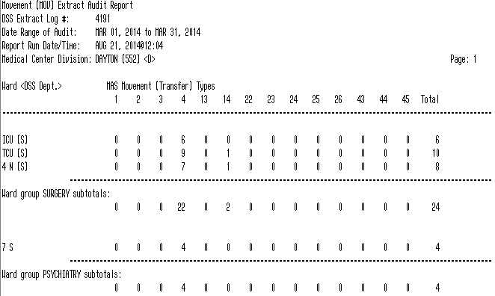
Example: Exported Physical Movement Extract Audit Report
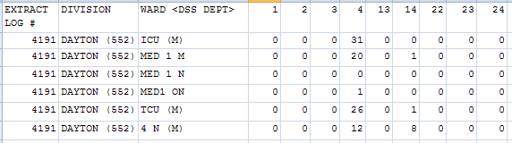

Prosthetics (PRO) Extract Audit
Use this option to print the PSAS HCPCS Cost Report from the PROSTHETICS EXTRACT file (#727.826). Sites that are multidivisional prosthetics sites may choose to generate a specific report for one division or a combined report for all divisions.
The report is divided into two parts and includes the following:
Summary | Detail
NPPD group summary.  Data is reported in three sections: New, Rental and Repair | Individual patient detail within an NPPD Line Item.
VA, Commercial, and Total quantities.  Total Cost and Average Commercial Cost. | HCPCS code and description.  Delivery Date, Quantity, and Cost.  Type (i.e., VA or Commercial, Initial or Repair).  Station Number is also displayed for multidivisional Prosthetics sites.
Within each NPPD Group, the summary data for each NPPD Line Item is displayed, followed by the group totals. Summary totals are also provided for New, Rental and Repair sections. | Sort order is by Delivery Date.
Example: Exported Summary Report for PRO Extract Audit
Select Extract Audit Reports Menu Option: PRO Prosthetics (PRO)Extract Audit

Setup for PRO Extract Audit Report --

Select DSS EXTRACT LOG RECORD NUMBER: 3897 05-22-13 Prosthetics

Extract: Prosthetics #3897

Start date: FEB 01, 2013
End date: FEB 28, 2013
# of Records: 5748
Station: DAYTON

The extract which you have chosen to audit
was transmitted to Austin/DSS on MAY 22, 2013.

Do you want to continue with this audit report? NO// y YES

You can narrow the date range, if you wish.

The Start Date can't be earlier than FEB 01, 2013,
or later than FEB 28, 2013.

Select Start Date: FEB 01, 2013// (FEB 01, 2013)

The End Date can't be earlier than FEB 01, 2013
(the Start Date you selected), or later than FEB 28, 2013.

Select End Date: FEB 28, 2013// (FEB 28, 2013)

Select one of the following:

D DETAIL
S SUMMARY

Type of Report: SUMMARY// s SUMMARY

Do you want the output in exportable format? NO// YES

Gathering data for export...

To ensure all data is captured during the export:

1. Select 'Logging...' from the File Menu. Select your file, and where to save.
2. On the Setup menu, select 'Display...',then 'screen' tab and modify 'columns'
setting to at least 225 characters.
3. The DEVICE input for the columns should also contain a large enough
parameter (e.g. 225). The DEVICE prompt is defaulted to 0;225;99999 for you.
You may change it if need be.
Example: DEVICE: 0;225;99999 *Where 0 is your screen, 225 is the margin width
and 99999 is the screen length.

NOTE: In order for all number fields, such as SSN and Feeder Key, to be
displayed correctly in the spreadsheet, these fields must be formatted as Text
when importing the data into the spreadsheet.

DEVICE: 0;225;99999//

Example: Exported Summary Report for PRO Extract Audit

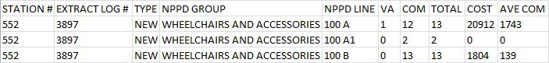
Example: Summary Report Screen Print for PRO Extract Audit
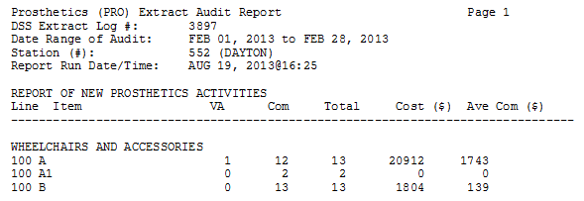
Example: Exported Detail Report for PRO Extract Audit
Select Extract Audit Reports Menu Option: Prosthetics (PRO) Extract Audit

Setup for ECS Extract Audit Report --

Select DSS EXTRACT LOG RECORD NUMBER: 3969 06-20-13 Prosthetics

Extract: Event Capture #3969

Start date: FEB 01, 2013
End date: FEB 28, 2013
# of Records: 17419

The extract which you have chosen to audit
was transmitted to Austin/DSS on JUN 20, 2013.

Do you want to continue with this audit report? NO// YES

You can narrow the date range, if you wish.

The Start Date can't be earlier than FEB 01, 2013,
or later than FEB 28, 2013.

Select Start Date: FEB 01, 2013// (FEB 01, 2013)

The End Date can't be earlier than FEB 01, 2013
(the Start Date you selected), or later than FEB 28, 2013.

Select End Date: FEB 28, 2013//02102013 (FEB 10, 2013)

Do you want the ECS extract audit report for all Locations? NO// YES

Select one of the following:
D DETAIL
S SUMMARY
Type of Report: SUMMARY// DETAIL

1. WHEELCHAIRS AND ACCESSORIES
2. ARTIFICIAL LEGS
3. ARTIFICIAL ARMS AND TERMINAL DEVICES
4. BRACES AND ORTHOTICS
5. SHOES/ORTHOTICS
6. NEUROSENSORY AIDS
7. RESTORATIONS
8. OXYGEN AND RESPIRATORY
9. MEDICAL EQUIPMENT, MISC., ALL OTHER NEW
10. REPAIR

Select NPPD Group : (1-10): 1

1. 100 A MOTORIZED
2. 100 A1 SCOOTERS
3. 100 B MANUAL CUSTOM
4. 100 C MANUAL A/O
5. 100 D ACCESSORIES
6. 100 E CUSHION FOAM
7. 100 F CUSHION SPEC
8. 100 G CARRIERS
9. 100 H NSC VAN MODS
10. 100 I SCOOTER ACCESSORIES

Select NPPD Line : (1-10): 1

Do you want the output in exportable format? NO// Y

Gathering data for export...

To ensure all data is captured during the export:

1. Select 'Logging...' from the File Menu. Select your file, and where to save.
2. On the Setup menu, select 'Display...',then 'screen' tab and modify 'columns'
setting to at least 225 characters.
3. The DEVICE input for the columns should also contain a large enough
parameter (e.g. 225). The DEVICE prompt is defaulted to 0;225;99999 for you.
You may change it if need be.
Example: DEVICE: 0;225;99999 *Where 0 is your screen, 225 is the margin width
and 99999 is the screen length.

NOTE: In order for all number fields, such as SSN and Feeder Key, to be
displayed correctly in the spreadsheet, these fields must be formatted as Text
when importing the data into the spreadsheet.

DEVICE: 0;225;99999//

Example: Exported Detail Report for PRO Extract Audit

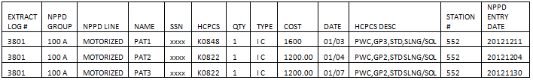
Example: Detail Report Screen Print for PRO Extract Audit
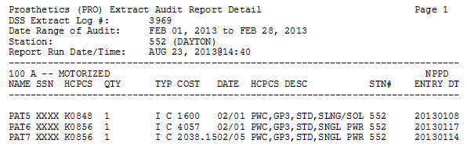

Radiology (RAD) Extract Audit
Use this option to print a summary report from the RADIOLOGY EXTRACT file (#727.814) which displays the total count of each radiological procedure within a Feeder Location.
Example: Radiology Extract Audit Report
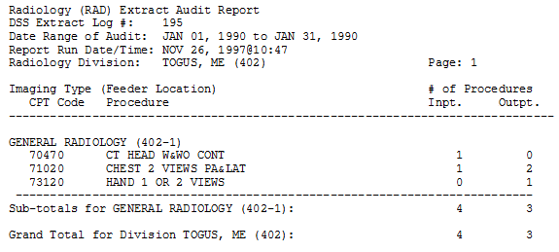
Example: Exported Radiology Extract Audit Report
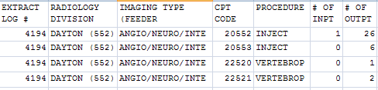

Surgery (SUR) Extract Audit
Use this option to print a summary report from the SURGERY EXTRACT file (#727.811). The report displays the number of surgical procedures and surgical cases performed in O.R. and Non-O.R. locations.
Example: Surgery Extract Audit Report
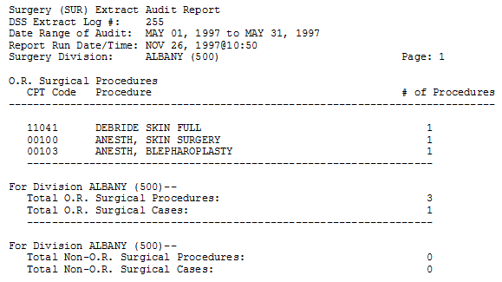
Example: Exported Surgery Extract Audit Report
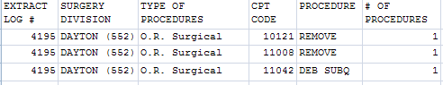

Treating Specialty Change (TRT) Extract Audit
Use this option to print a summary report from the TREATING SPECIALTY CHANGE EXTRACT file (#727.817) which displays the total number of losses within each Treating Specialty of a medical center service.
Example: Treating Specialty Change Extract Audit Report
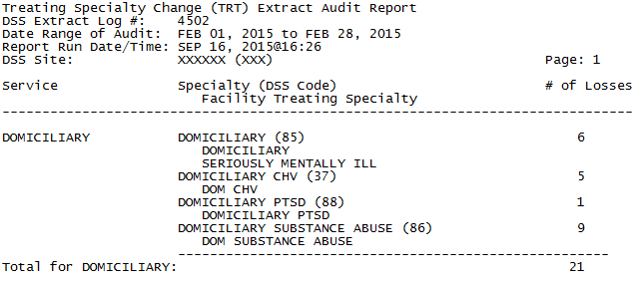
Example: Exported Treating Specialty Change Extract Audit Report
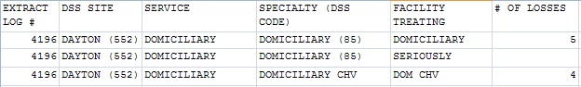

Transmission Management
This section initiates and controls the transmission of data from the extract files to AITC. This menu provides users with the capability to purge the IVP, UDP or VBECS holding files. It also provides users with the capability to delete an individual or range of DSS Extract files.
Choosing the Transmission Management option from the Extract Managers Menu will display the following menu and options.
Example: Transmission Management Options on Extract Managers Menu
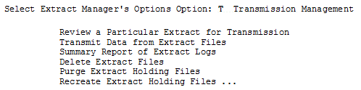

Review a Particular Extract for Transmission
Use this option to review a particular extract to verify the transmission of messages to the AITC. The only prompts are for the extract log record number and a print device. The output includes the following information:
- Extract log record number
- Extract name
- Run date
- Division
- Transmission message numbers
- Whether or not the extract was purged
- Message status
Example: Extract for Transmission
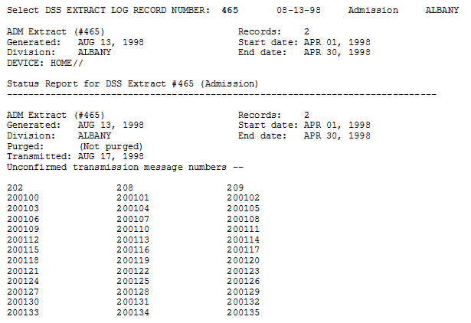

Transmit Data from Extract Files
To receive mail messages confirming transmission of extract data, you must be enrolled in the DSS mail group associated with the extract being transmitted.
Use this option to transmit a series of mail messages containing data from an individual extract to the AITC. Members of the associated mail group(s) will receive confirmation messages indicating that an extract was completed, transmitted, and received in Austin. You can only transmit extracts for your division.
Example: Transmit Data from Extract Files
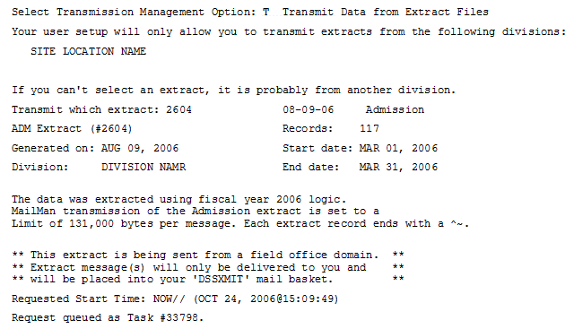
Example: Sample Mail Message - Completed Extracted Data
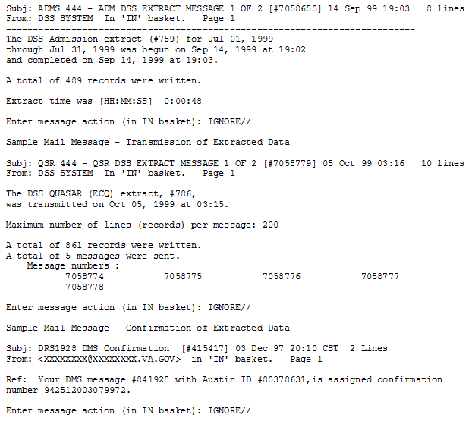

Summary Report of Extract Logs
Use this option to print a summary report from the EXTRACT LOG file (#727). The only prompts are for starting and ending dates and a print device. The output includes the following information:
- Extract number
- VistA Package
- Data set dates (date range)
- Record count
- Date transmitted
- Date purged
- Date Extracted
- Data Month
- Msg Unconf (Message Number)
- Requestor
The report prints properly to a 132-column output
Example: Summary Report Extract Logs
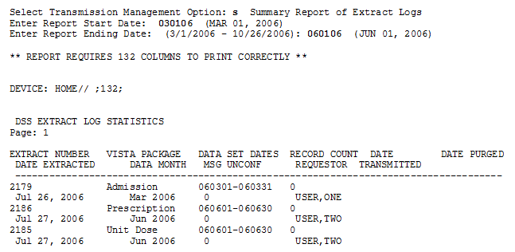
Example: Exported Summary Report Extract Logs
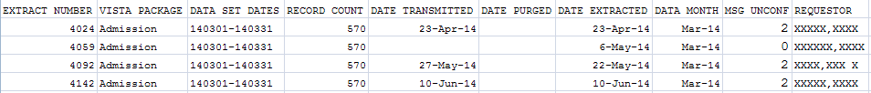

Delete Extract Files
This option can be used to delete individual extracts residing in files #727.802 through #727.833, or a range of extracts. Also, holders of the ECXMGR Security Key may only delete extracts that are associated with a division assigned in the NEW PERSON file (#200).
Any existing extract may be deleted (including transmitted and untransmitted) and extracts that did not run to completion due to errors or system problems.
Choosing a range of extracts could mean an excessively large number of records to be deleted and it may be very resource intensive. Please be sure to queue this for non-peak hours and limit the number of extracts to be deleted in a single queued session.
Example: Delete Extract File Option
This option will allow you to delete an
individual or a range of DSS extracts files.

Care must be taken for several reasons:

- You can delete ANY existing extract. This includes transmitted and non-
transmitted extracts as well as extracts that did not run to completion
due to errors or system problems.
- Choosing a range of extracts could mean an excessively large number
of records and be very CPU intensive.
Please be sure to queue this deletion for off-hours and
limit the number of extracts to be deleted per a single queued session.

Delete Extract Files?? NO// y YES

...one moment please

Do you want to print a list of extracts that can be deleted? NO//
You will not be able to select an extract that is not from your division.

Select extracts to be deleted: (3794-4071): 3794

I will delete the following extract(s):
#3794 - Event Capture 01/01/2013 to 01/31/2013

Is this OK? NO// YES

Purge Extract Holding Files
Use this option to purge the data that resides in the holding files for the IVP or UDP extracts, or VBECS. A prompt will appear for the start and end dates. Dates can be entered as 10 15 08, 10/15/08, or 10/15/2008.
The IV EXTRACT DATA file (#728.113) and UNIT DOSE EXTRACT DATA file (#728.904) can become quite large if appropriate purging is not performed. This option will purge the data from these files by date range. It is recommended that records over two fiscal years old be purged from IV EXTRACT DATA file (#728.113) and UNIT DOSE EXTRACT DATA file (#728.904).
VBECS holding files can also be purged. Once purged, these files cannot be recreated for that time period.
Purging of any local VistA extract data or VistA source of extract data (i.e., lab data, etc.) is not recommended until your facility has successfully created extracts, transmitted them to the AITC, audited the counts, loaded the data into DSS and is content with the results.
When the Purge ends, a confirmation message will be created on MailMan.
Example: Purge Holding Files
Select Transmission Management Option: Purge Extract Holding Files

This option will allow you to purge:
1. data that resides in the "holding files" for the IVP and UDP extracts.
2. data that resides in the "holding file" for the VBECS extract

Care must be taken for several reasons:
- The IVP, UDP and VBECS "holding" files are intermediate files that
are populated "realtime" by inpatient pharmacy and VBECS activity.
These files are then used to generate the IVP, UDP and VBECS extracts.
NOTE: The VBECS files CANNOT be regenerated.
Once it is purged for a date range, extracts can no longer be
generated for that time period.

Purge (I)VP data, (U)DP data or (V)BECS data? IVP Holding File

This file currently holds IVP data from <Oct 13, 1999> to <Apr 01, 2013>.

Beginning date for purge: 1/1/13 (JAN 01, 2013)
Ending date for purge: 1/31/13 (JAN 31, 2013)

I will purge the IVP holding file from <Jan 01, 2013> to <Jan 31, 2013>.

Is this OK? NO// y YES
Example: Confirmation Message
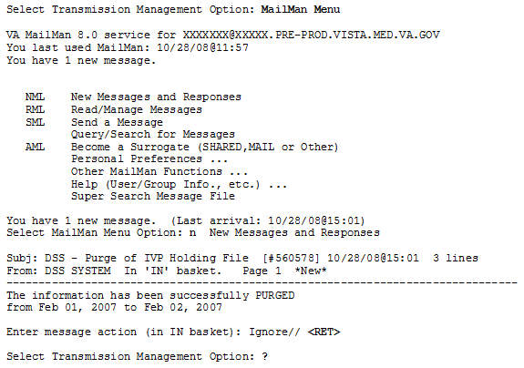

Recreate Extract Holding Files
Use this option to recreate an IVP or UDP Extract holding file which has been purged at the AITC. You will be prompted for the start and end dates. A background task will be launched. When that task ends, it will create a confirmation message on MailMan.
It is unusual to purge and recreate these files. They normally are NOT purged.
The Recreate applies to the entire parent station.
To recreate an IVP or UDP extract,
- Run the Purge for the desired date range.
- Dates can be entered as 10 15 08 or 10/15/08 or 10/15/2008.
- Check MailMan for a confirmation message that the Purge has completed successfully.
- Run the Recreate for the same date range.
- If you did not run the Purge and data exists for the requested time period, you will be prompted to do so.
- Check MailMan for a confirmation message that the Recreate has completed successfully.
- Run the IVP or UDP Extract.
- Compare the record count from the recreated extract to the record count of the original extract. The counts should be close but may be slightly different due to timing issues.
Example: Example of Recreate
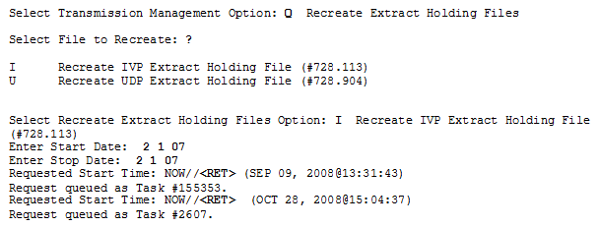
When the Recreate is complete, a MailMan message will be sent to you. To view the message, type “MailMan Menu” at the prompt. You will see the following lines.
Example of Confirmation Message for Recreate
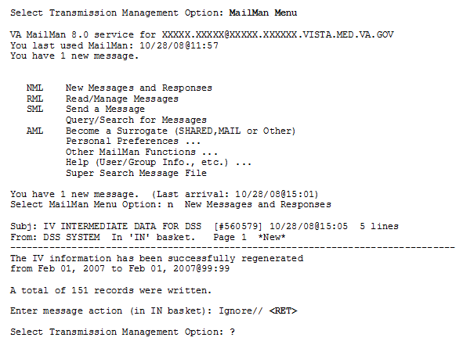

Glossary
Term | Definition
Action to Send Code | Indicates which code should be sent to the DSS commercial software (e.g., stop code, credit stop code, or both).
ADPAC | Acronym for Automated Data Processing Application Coordinator
ADM | Abbreviation for Admission Extract
AITC | Acronym for Austin Information Technology Center
BCM | Abbreviation for BCMA Extract
BCMA | Acronym for Bar Code Medication Administration
CBOC | Acronym for Community Based Outpatient Clinic
CLI | Abbreviation for Clinic Extract
CPT | Acronym for Current Procedural Terminology
Credit Stop Code | The Credit Stop Code (from the HOSPITAL LOCATION file [#44]) as determined by Medical Administration Service (MAS).
CSHD | Acronym for Customer Support Help Desk
DSS | Acronym for Decision Support System (now known as MCAO)
DSS Credit Stop Code | The Credit Stop Code as determined by MCA.
DSS Product Department | A code associated with products or services, which assists in the categorization and costing of those products. At this time, only medical center wards are being associated with a DSS Product Department in the DSS WARD file (#727.4). The DSS Product Department consists of a minimum of 4 characters as:  ABBCxxx  A = DSS CODE in NATIONAL SERVICE file (#730)  BB = DSS PRODUCTION UNIT CODE in DSS PRODUCTION UNIT file (#729)  C = DSS DIVISION IDENTIFIER in DSS DIVISION IDENTIFIER file (#727.3)  xxx = A suffix of not more than three characters which must be numeric digits or uppercase alpha characters. The first character of the string may be "-", but that is not recommended.
DSS Division Identifier | A single character code, either numeric (but not zero) or an uppercase alpha character. The character used in VistA file #727.3 (DSS DIVISION IDENTIFIER) as division identifier should exactly match the identifier associated with a medical center division in DSS/Austin.
DSS Production Unit | A two character code which may contain both numeric and uppercase alpha characters. These DSS-compatible codes are based on the FMS sub-cost center scheme to categorize production unit output. The DSS PRODUCTION UNIT file (#729) holds the production unit codes approved for use by DSS.
DSS Stop Code | The Stop Code as determined by MCA.
ECS | Abbreviation for Event Capture System Extract
ECQ | Abbreviation for QUASAR Extract
Extract | Management tool used to track and account for procedures and delivered services, which are not handled in any existing VistA package.
Extract Files | The files that hold the data that has been extracted via the DSS Extract software.
Feeder Key | The product for workload extracted.
Feeder Location | The site location of data extracted.
IVP | Abbreviation for IV Detail Extract
LAB | Abbreviation for Laboratory Extract
LAR | Abbreviation for Lab Results Extract
LBB | Abbreviation for Blood Bank Extract
MAS | Acronym for Medical Administration Service
MCA | Acronym for Managerial Cost Accounting
MCAO | Acronym for Managerial Cost Accounting Office (formerly known as DSO)
MOV | Abbreviation for Transfer and Discharge Extract
NDC | Acronym for National Drug Code
NDF | Acronym for National Drug File
PRE | Abbreviation for Prescription Extract
PRO | Abbreviation for Prosthetics Extract
Provider | The actual provider of care performing the procedure. This provider can be a doctor, nurse, technician or any designated team of medical professionals.
QUASAR | Acronym for Quality: Audiology and Speech Pathology Audit & Review
RAD | Abbreviation for Radiology Extract
SSN | Acronym for Social Security Number
Stop Code | The Stop Code (from the HOSPITAL LOCATION file [#44])as determined by Medical Administration Service (MAS).
SUR | Abbreviation for Surgery Extract
TRT | Abbreviation for Treating Specialty Change Extract
UDP | Abbreviation for Unit Dose Local Extract
VA | Acronym for Department of Veterans Affairs
VHA | Acronym for Veterans Health Administration
VistA | Acronym for Veterans Health Information Systems and Technology Architecture
Volume | Volume is associated with the number of procedures performed or the length of time actually spent performing the procedures.
YTD | Acronym for Year-to-Date

Index

Active MAS Wards for the Fiscal Year Print 69
Add/Edit Lab Results Translation Table 15
Admission (ADM) Extract Audit 86
Admissions Extract (ADM) 77
All Active Clinics Option 56
All Clinics Option 55
All Inactive Clinics Option 57
Approve Reviewed DSS Clinic Worksheet 60
BCM Unusual Volume Report 38
BCMA Extract (BCM) 77
Before You Start Using the Software 7
Blood Bank Extract (LBB) 81
CBOC Activity Report 9
CHAR4 Codes List 51
Clinic and Stop Codes Validity Report 64
Clinic Edit Log Report 66
Clinic Visit Extract (CLI) 77
Clinics and DSS Stop Codes Print 53
Components of this User Manual 6
Cost by PSAS HCPC Report 43
CPT Inquiry 10
Create DSS Clinic Stop Code File 51
Delete Extract Files 106
DSS Department Management 11
Duplicate Clinics Option 56
Enter/Edit Clinic Parameters 59
Enter/Edit DSS Ward 11
Enter/Edit IV Room Division 71
Event Capture 12
Event Capture Local (ECS) Extract Audit 88
Event Capture Local Extract (ECS) 78
Existing Clinic Entries 53
Export Clinic Review Report Option 57
Extract Audit Reports 84
Extract Audit Reports Menu 85
Extract Manager’s Menu 9
Fiscal Year Logic – DSS Testing Only 81
Generate the Inpatient Setup Extract 68
Introduction 5
IV Extract (IVP) 78
IVP Extracts Incomplete Feeder Key Report 26
IVP Unusual Cost Report 31
IVP Unusual Volume Report 34
Lab Extract (LAB) 78
Lab Results DSS LOINC® Code Report 18
Lab Results Extract (LAR) 78
Lab Results Extract Untranslatable Results Report 17
Laboratory 15
Laboratory (LAB) Extract Audit 90
Laboratory Blood Bank (LBB) Audit Reports 92
Laboratory Blood Bank (LBB) Comparative Report 92
Laboratory Blood Bank (LBB) Pre-Extract Audit 93
Laboratory Results (LAR) Extract Audit 91
Logon/Accessing DSS Options 8
Maintenance Menu 9
New Clinic Entries 52
Online Help 6
Orientation 6
Package Extracts 75
Pharmacy 19
Pharmacy Edit and Edit Log 19
Pharmacy Extracts Incomplete Feeder Key Report 24
Pharmacy Extracts Unusual Cost Report 29
Pharmacy Extracts Unusual Volume Report 33
Pharmacy NDC Lookup 71
Pharmacy Volume Edit 19
Pharmacy Volume Edit Log 23
Physical Movement (MOV) Extract Audit 94
PRE Extracts Incomplete Feeder Key Report 25
PRE Unusual Cost Report 30
PRE Unusual Volume Report 33
Prescription Extract (PRE) 79
Primary Care Team Print 70
Print Feeder Keys 41
Print Feeder Locations 42
Print IV Room Worksheet 71
Prosthetic Extracts Unusual Cost Report 45
Prosthetics 43
Prosthetics (PRO) Extract Audit 95
Prosthetics (PRO) YTD HCPCS Report 46
Prosthetics (PRO) YTD Laboratory Report 49
Prosthetics Extract (PRO) 79
Purge Extract Holding Files 107
QUASAR (ECQ) Audit 87
Quasar Extract (ECQ) 79
Radiology (RAD) Extract Audit 99
Radiology Extract (RAD) 80
Recreate Extract Holding Files 108
Related DSS Manuals 5
Review a Particular Extract for Transmission 102
SAS Extract Audit Reports 81
SAS Extracts Audit Reports Menu 82
SAS Prescription Audit Report 82
SAS Radiology Audit Report 83
SAS Surgery Audit Report 84
Setup for DSS Clinic Information 50
Setup for Inpatient Census Information 67
Setup for Inpatient Medications Information 70
Setup Required DSS Information 7
Stop Code Non-Conforming Active Clinics Report 61
Stop Code Non-Conforming Both Active and Inactive Clinics 63
Stop Code Non-Conforming Clinics Report 60
Stop Code Non-Conforming Inactive Clinics 62
Summary Report of Extract Logs 105
SUR Volume Report 73
Surgery 73
Surgery (SUR) Extract Audit 100
Surgery Extract (SUR) 80
Surgery Extracts Unusual Volume Report 74
The Security Keys Structure 7
Transfer and Discharge Extract (MOV) 80
Transmission Management 102
Transmit Data from Extract Files 103
Treating Specialty Change (TRT) Extract Audit 101
Treating Specialty Change Extract (TRT) 80
Trial for Setup Extract 67
UDP Extracts Incomplete Feeder Key Report 28
UDP Unusual Cost Report 32
UDP Unusual Volume Report 36
UDP/IVP Source Audit Report 40
Unit Dose Extract (UDP) 80
Unreviewed Clinics Option 57
Unusual Volume Report for Event Capture 12
User Responses 6

Feeder Key Transmission
The Feeder Key for the Clinic Extract is transmitted in the following format.
SSSCCCTTT4444N
These characters are determined by the ACTION TO SEND code as indicated in the following table.
Action to Send Code | Description
1 :SEND STOP CODE | SSS is the Stop Code.  CCC=000.  TTT is the length of appointment.  PPPP=0000.
4 :SEND BOTH AS ONE RECORD WITH CHAR4 CODE | SSS is the Stop Code.  CCC is the Credit Stop Code. If no Credit Stop Code assigned then “000”  TTT is the length of appointment.  4444 is the CHAR4 Code.  N if a no-show, otherwise ‘0’ (zero).
5 :SEND BOTH AS ONE RECORD WITHOUT CHAR4 CODE | SSS is the Stop Code.  CCC is the Credit Stop Code.  TTT is the length of appointment.  4444=0000.  N if a no-show, otherwise ‘0’ (zero).

Create a LAR Translation Table
A translation table is required to convert entries in the results field of the LAR extract from a free text to a numeric value for all types of lab tests. The translation table is a new table for the DSS VistA Extract Package. LAR TRANSLATION TABLE will convert free text results to a numeric value for all lab tests.
The translated numeric values are:
0 - Negative, Non-Reactive.
1 - Positive, Reactive.
2 - Borderline, Indeterminate.
3 - Test not Performed, Qty not sufficient or other reason.
5 - Result cannot be translated.
The Lab Results free text field contains many different coding schemes to indicate whether the results are negative or positive. The list of text with the translated values is as follows:
RAW Translation RAW Translation
Negative 0 EQUIV 2
Positive 1 NRG 5
NEGATIVE 0 N 0
POSITIVE 1 R 1
Neg 0 Borderline 2
Pos 1 NEG. 0
nonreactive 0 POS. 1
NONREATIVE 0 ND 0
reactive 1 Reactive 1
REACTIVE 1 Detected. 1
NEG 0 React 1
POS 1 Nonreact 0
NOTDET 0 WK POS 1
DETEC 1 +/-=pos 2
NON REAC 0 LSG 5
REAC 1 Reactive* 1
WK.POS 1 =+pos 1
WK.POS. 1 NEGATIV 0
NEG# 0 ND 0
POS# 1 INCONC. 2
BRDLINE 2 DONE 5
NR 0 NEH 5
Non-react 0 MEG 5
BRDLNE 2 P 1
**pos 1 NRG 5
***pos 1 Repeat 2
BDL 2 NE 5
EQUIVOCAL 2 NGE 5

RAW Translation
REM 5
ND 0
NRE 5
See com 5
See rpt 5
Reac 1
NREACT 0
Type 1 5
2b 5
3a 5
BAS 5
N-I 5
Pend 5
RPC 5
QNS 3
P 1
FFT 5
+ 1
- 0

Note:
Any value not in the table should return a “5”.
The sites will be responsible for maintaining/updating the table.
Translations cannot change the meaning of the free text field.
Non-numeric reported values for all tests would be stored in the translation field and available to Ad Hoc and SQL.
In many cases, it may take a long time to run this report (possibly more than an hour or two). Your screen may be tied up for some time once you set the report to run

Exporting a Report to a Spreadsheet
- Select Display from the Setup menu.
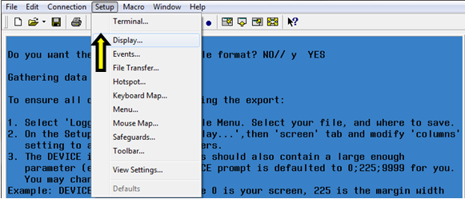

- On the Screen tab, modify the number of Columns to at least 225. Click OK.
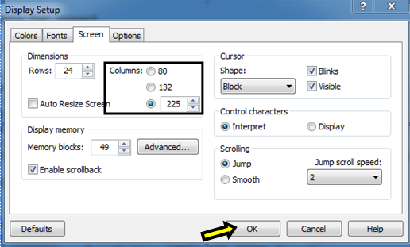

- Select Logging… on the File menu.
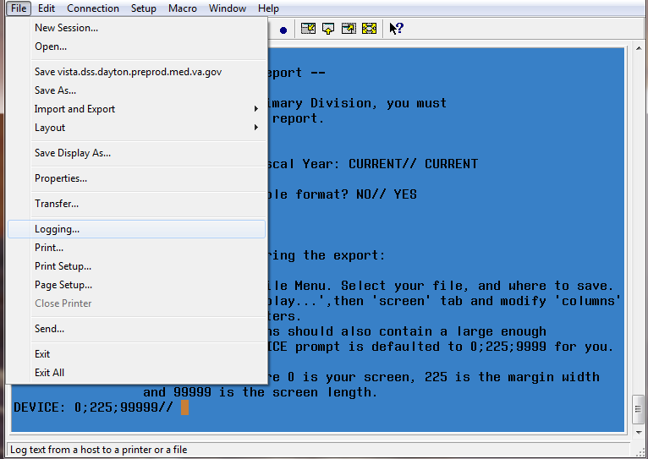

- On the Logging popup, click to select Logging on. Then, select the Disk option and name the file. Click Browse…
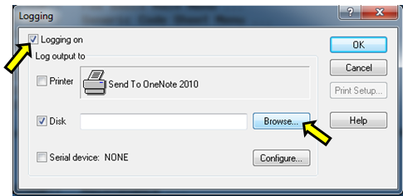

- Select the folder where the text file will be saved and click Save.
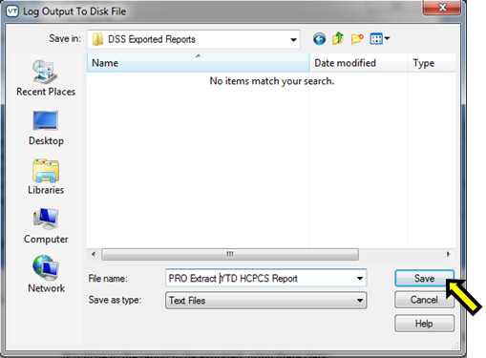

- The file will be created in the folder identified.

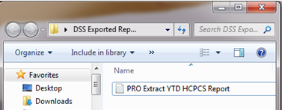

- Press Enter on your keyboard to keep the parameters at the DEVICE: 0;225;99999// prompt.
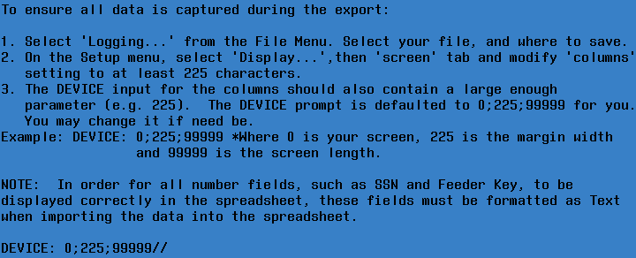

- Once the running of the report has completed, to turn off the logging select Logging… on the File menu. On the Logging popup, click to deselect Logging on.
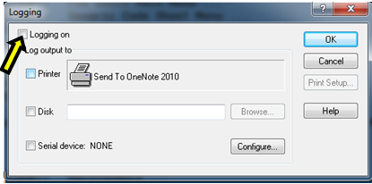

- Open a new Excel workbook. Click the Data tab and select From Text.
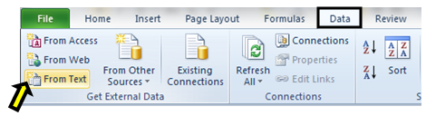

- Navigate to the folder where the file was created. Select the text file that was created and click Import.
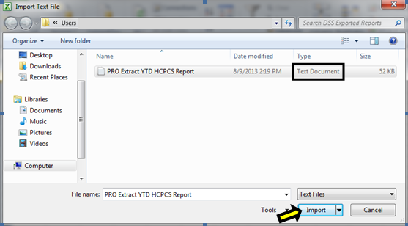

- Chose Delimited as the data type on the Text Import Wizard – Step 1 of 3 screens. Click Next.
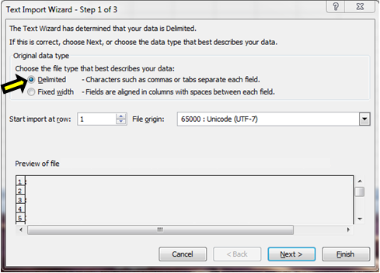

- Under delimiters, uncheck Tab, then check Other and type a caret (^) as your delimiter on the Text Import Wizard – Step 2 of 3 screen. Click Next.
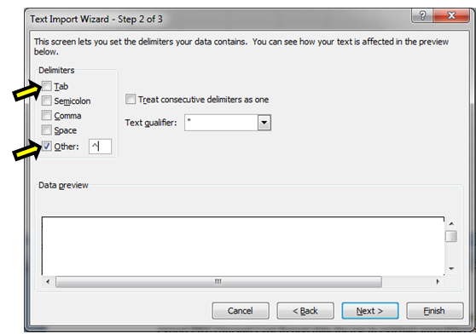

- Text will be chosen as the format for each column on the Text Import Wizard – Step 3 of 3 screens. In the Data Preview section of the screen, click to highlight the column and select Text as the data format. (Note: All columns can be selected at once if the first column is selected and then hold the shift key and move the scroll bar to the far right and select the last column). Click Finish after each column has been formatted.
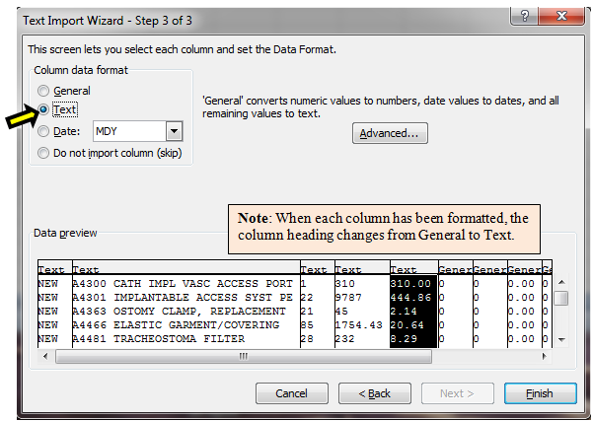

- Click OK when the Import Data screen appears.
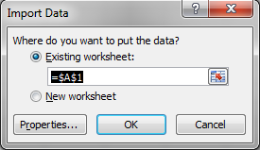
- The report will be created and displayed in Excel.

